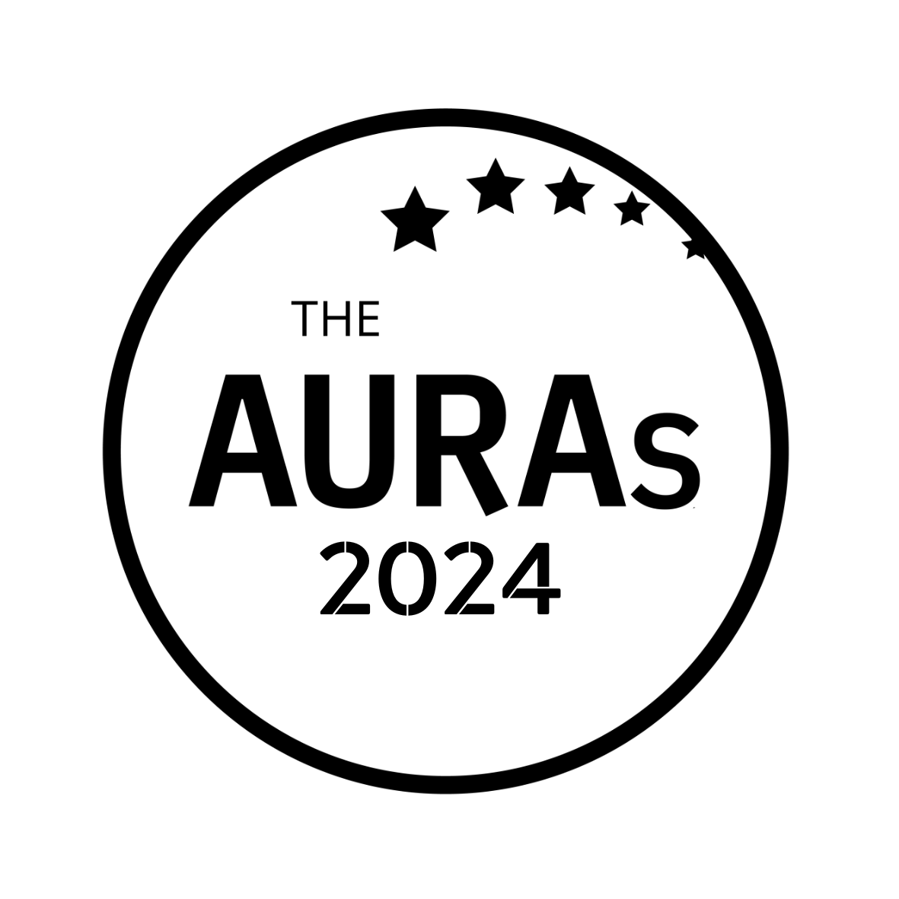

AGENCY NOMINATION FORM

BEST SMALL AGENCY

Award Criteria
This award is open to all agencies with either fewer than 25 members of staff and/or a turnover of under £1million turnover

Agency being nominated:

Contact at nominated agency:
Your name:

Your company:

Please tell us why you think this agency is worthy of an AURA. Include a brief description of the work that was undertaken but focus mostly on the reasons you think their contribution went above and beyond the ordinary. If you are able to support your nomination with stakeholder quotes or evidence of impact, even better.

Please submit this form to awards@aura.org.uk by 1800hrs Wednesday 15th May 2024

CONDITIONS OF ENTRY & KEY TIMINGS

- Only AURA members can nominate in this category

- A nomination can be in respect of a body of work done by an agency or a single project

- You may enter an agency for as many awards as you choose. Nominations close on Wednesday 15th May 2024

- AURA members will be invited to vote for shortlisted agencies in June-July 2024.

- Shortlisted agencies will be contacted by AURA by 10th June 2024. AURA will get in touch with the nominated contact shared in your submission.

- Winners will be announced on 25th July 2024 at the AURA Awards, which will be held at the Kia Oval, London

Thanks go to i-View Studios for supporting this award

