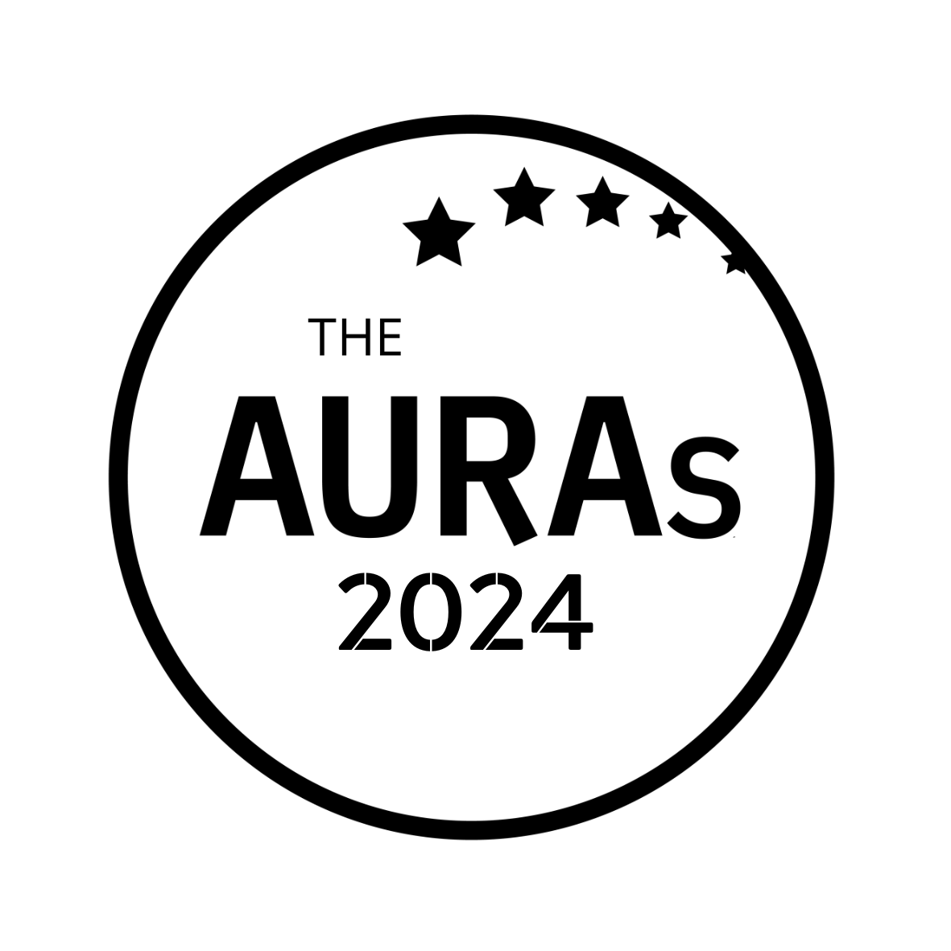
AGENCY NOMINATION FORM

STORYTELLING

Award Criteria
Putting the output of any research project in front of an internal audience can be a make or break moment. This award celebrates presentations that create ‘wow’ moments: agency communications that clients are proud to put in front of their stakeholders

Agency being nominated:

Contact name/email at nominated agency:
Your name:

Your company:

Please tell us why you think this agency is worthy of an AURA. Consider including:

- a brief description of how you have worked with them
- what stood out in their creation or delivery of brilliant insight comms
- the impact of their insight communication

If you are able to support your nomination with stakeholder quotes or evidence of impact, even better.

Please submit this form to awards@aura.org.uk by 1800hrs Wednesday 15th May 2024

CONDITIONS OF ENTRY & KEY TIMINGS

- Only AURA members can nominate in this category

- A nomination can be in respect of a body of work done by an agency or a single project

- You may enter an agency for as many awards as you choose. Nominations close on Wednesday 15th May 2024

- AURA members will be invited to vote for shortlisted agencies in June-July 2024.

- Shortlisted agencies will be contacted by AURA by 10th June 2024. AURA will get in touch with the nominated contact shared in your submission.

- Winners will be announced on 25th July 2024 at the AURA Awards, which will be held at the Kia Oval, London

With thanks to Verve for supporting this award

