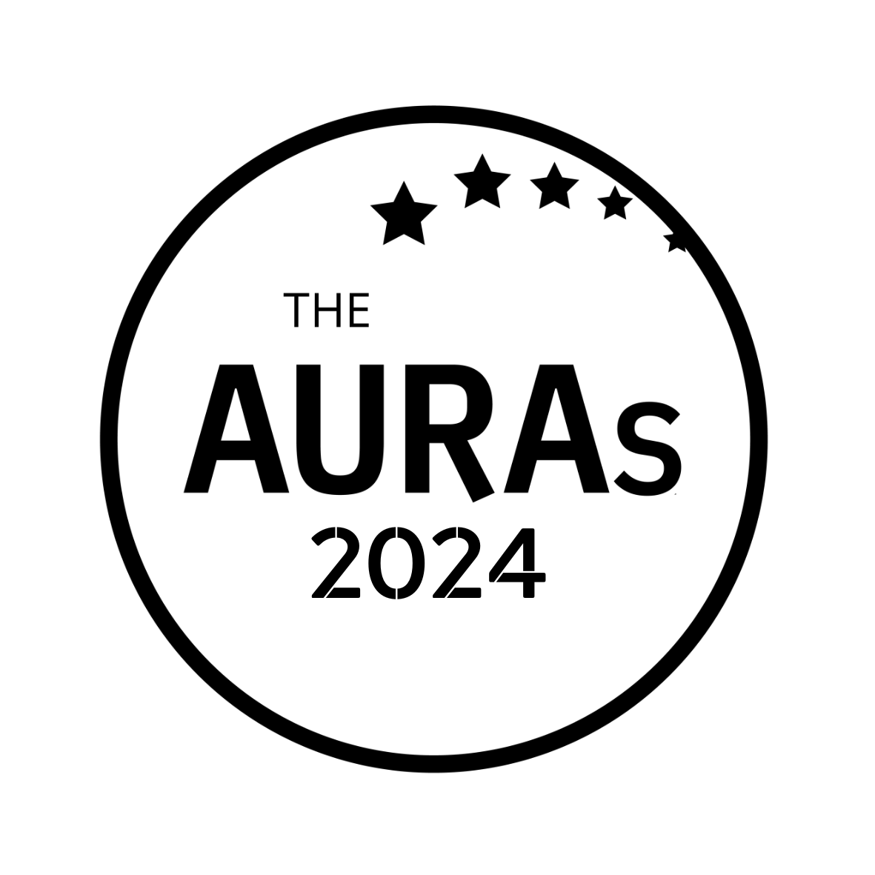
AGENCY NOMINATION FORM

TRUSTED PARTNER

Award Criteria
Strong relationships are at the heart of our business. This award is for agencies who have achieved Trusted Partner status – those who understands the business’s agenda and goes beyond the call of duty to help you deliver it

Agency being nominated:
Contact at nominated agency:
Your name:
Your company:

Please tell us why you think this agency is worthy of an AURA. Consider including:

- How long you’ve been working with the agency
- What makes them stand out
- How they have consistently exceeded your expectations

If you are able to support your nomination with stakeholder quotes or evidence of impact, even better.

Please submit this form to awards@aura.org.uk by 1800hrs Wednesday 15th May 2024

CONDITIONS OF ENTRY & KEY TIMINGS

- Only AURA members can nominate in this category

- A nomination can be in respect of a body of work done by an agency or a single project

- You may enter an agency for as many awards as you choose. Nominations close on Wednesday 15th May 2024

- AURA members will be invited to vote for shortlisted agencies in June-July 2024.

- Shortlisted agencies will be contacted by AURA by 10th June 2024. AURA will get in touch with the nominated contact shared in your submission.

- Winners will be announced on 25th July 2024 at the AURA Awards, which will be held at the Kia Oval, London

