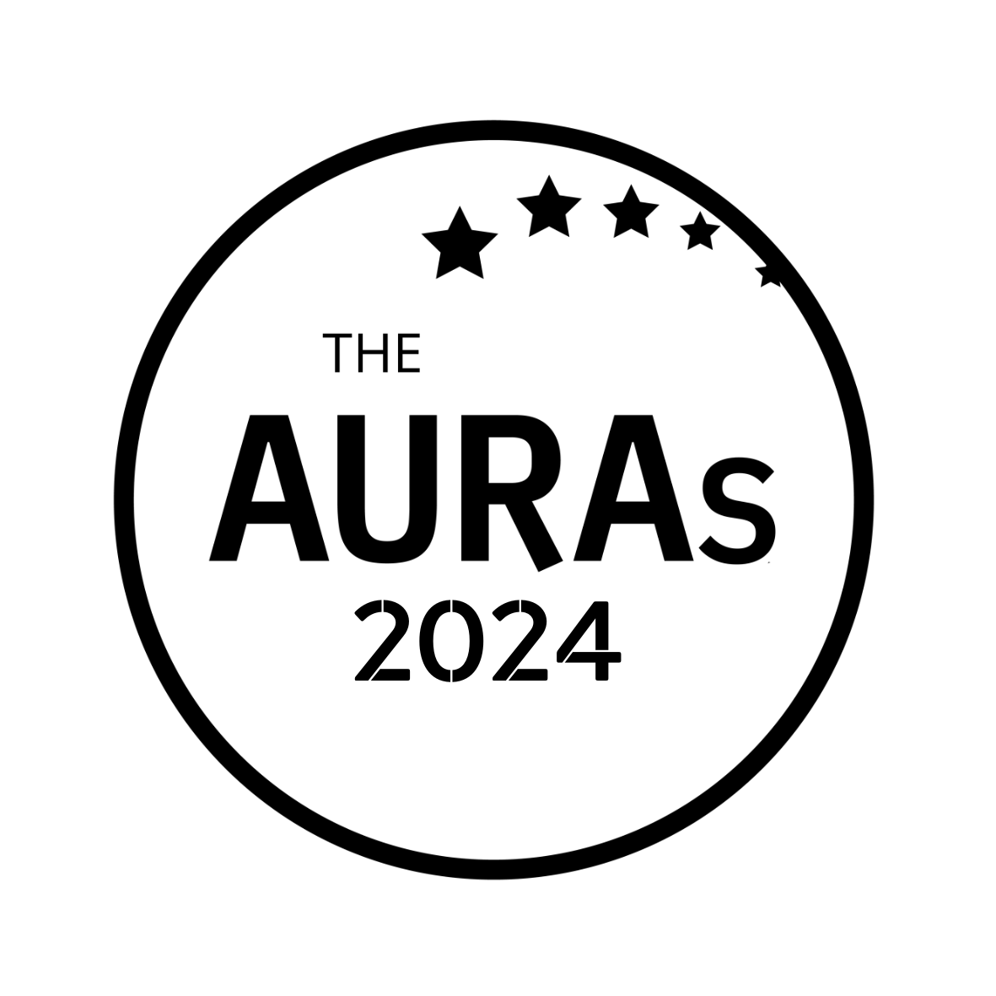

CLIENTSIDE TEAM OF THE YEAR ENTRY FORM

Award Criteria
This award recognises the quality, skills and impact AURA members have within their own organisations. This is a wide ranging award and could include nominations based on but not limited to areas such as earning influence amongst stakeholders; team building and personal development; going above and beyond on a particular project or a longer term reflection of a body of work that has been built up over time; delivering insight faster, better, cheaper insights etc.

Your name:

Your company:

Your email:

Number of people in your team:

YOUR NOMINATION

Please tell us why your team deserves to win this award. Wherever possible use examples to demonstrate.

Please submit this form to awards@aura.org.uk by 1800hrs Wednesday 15th May 2024

CONDITIONS OF ENTRY & KEY TIMINGS

- Only AURA members can nominate in this category

- A nomination can be in respect of a body of work done by an agency or a single project

- You may enter an agency for as many awards as you choose. Nominations close on Wednesday 15th May 2024

- The shortlisted finalists will be judged by an AURA judging panel.

- Shortlisted nominees will be contacted by AURA by 10th June 2024. AURA will get in touch with the nominated contact shared in your submission.

- Winners will be announced on 25th July 2024 at the AURA Awards, which will be held at the Kia Oval, London

With thanks to Fineline Market Research for supporting this award

