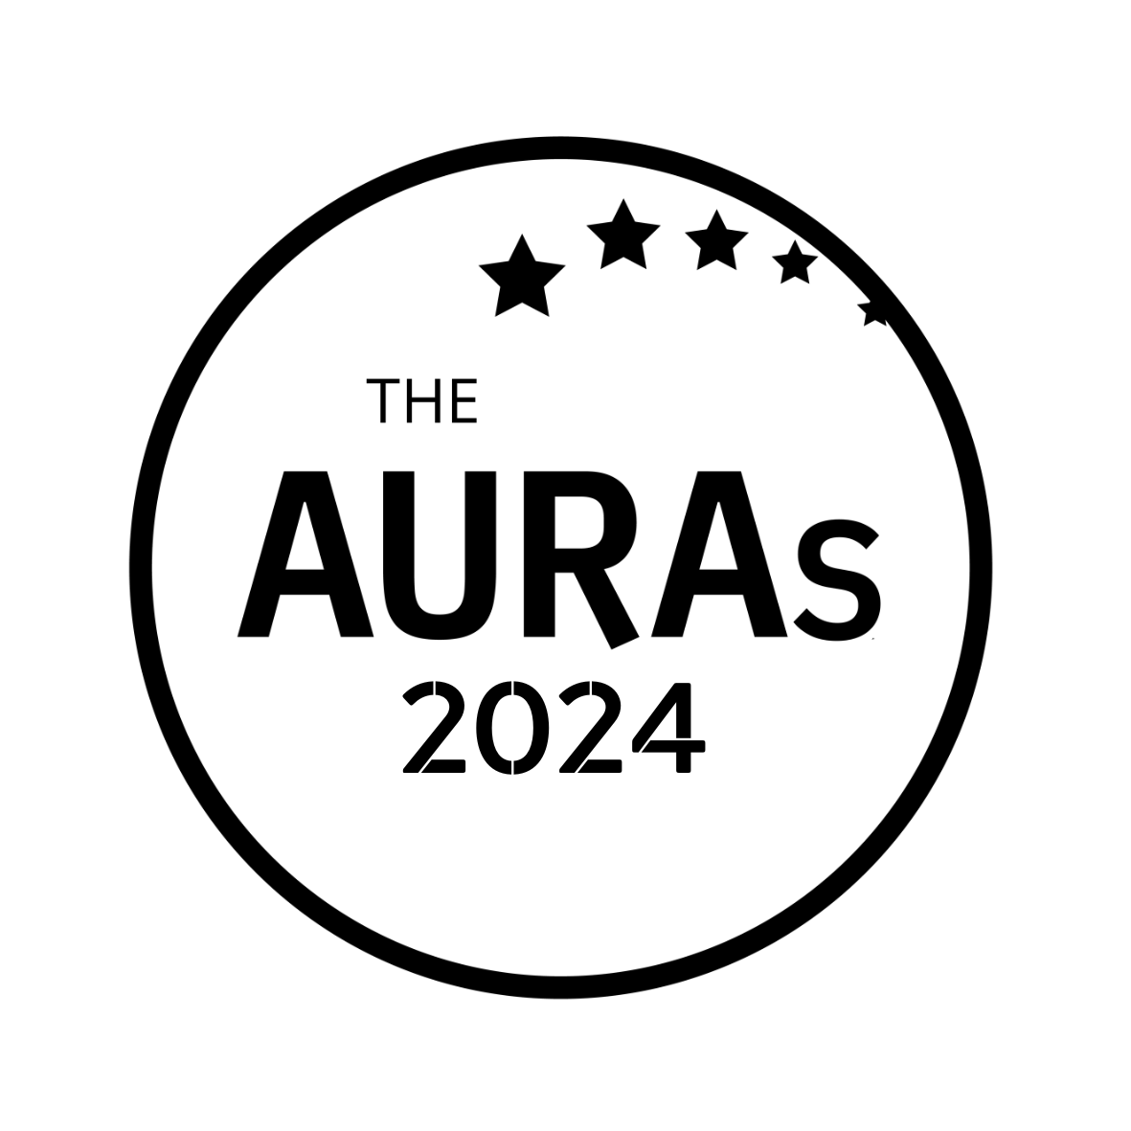

INDIVIDUAL IMPACT - CLIENTSIDE ENTRY FORM

Award Criteria
This award celebrates people at any level within your research organisation who have made an outstanding contribution or notable personal impact in the last year. It could be in relation to a particular project, a body or work and/or their contribution to the team as a whole

Name of the person you are nominating:

A contact email for them: (so we can get in touch if they are shortlisted)

Your name:

Your company:

Your email:

YOUR NOMINATION

Please tell us why you or this person deserves to win this award. Wherever possible please use examples to help us understand what makes them special. You are welcome to include endorsements, but these are optional.

Please submit this form to awards@aura.org.uk by 1800hrs Wednesday 15th May 2024

CONDITIONS OF ENTRY & KEY TIMINGS

You may enter more than one nominee for this award. Nominations close on Wednesday 15th May 2024

The shortlisted finalists will be judged by an AURA judging panel.

Shortlisted nominees will be contacted by AURA after 10th June 2024. AURA will get in touch with the nominated contact shared in your submission.

Winners will be announced on 25th July 2024 at the AURA Awards, which will be held at the Kia Oval, London

Thanks go to Truth Consulting for supporting this award

