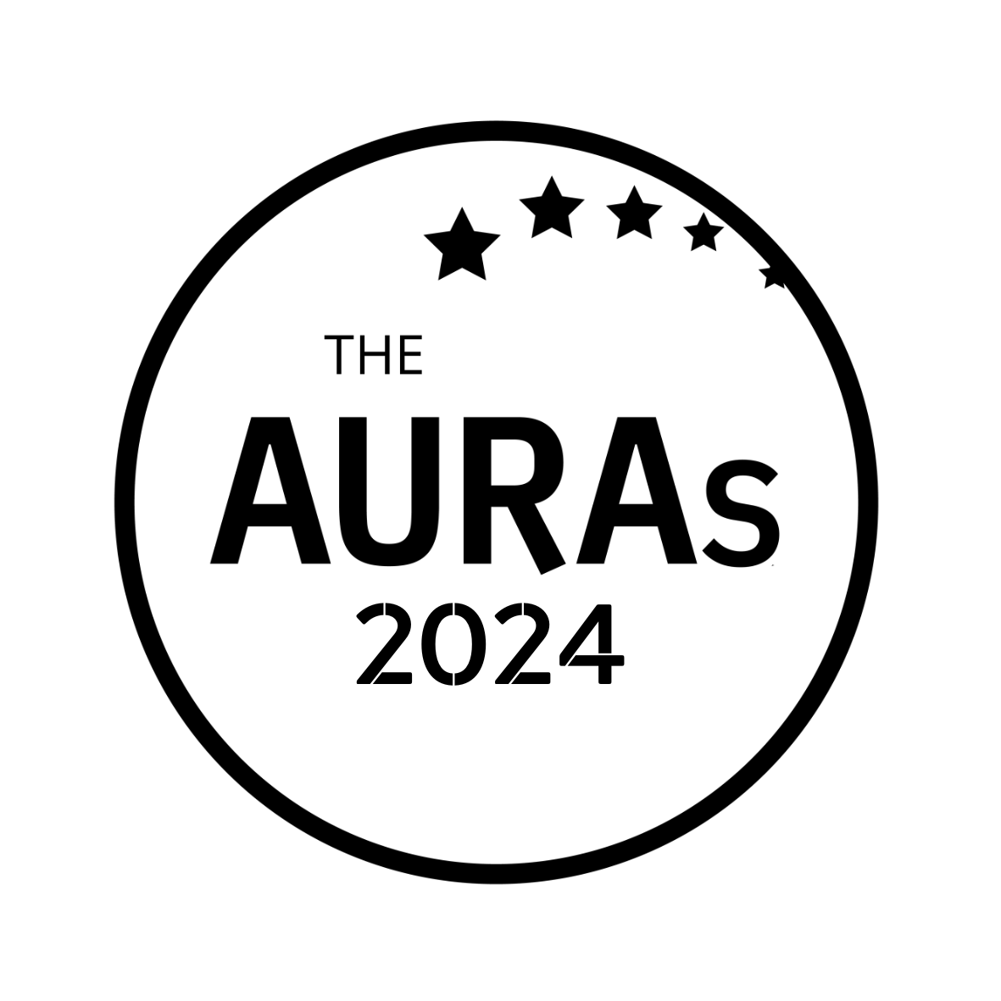

INSIGHT IMPACT ENTRY FORM

Award Criteria

This award is given to the best case study from a client and/or client-agency collaboration for demonstrating the Impact of Insight on their business through:

- the bottom line improvements/successes; and/or
- engaging difficult to reach stakeholders; and/or
- changing the opinions of customers through effective and creative use of insight

Your name:

Your company:

Contact email:

You have up to 750 words for your entry. The shortlisted entries will be those case studies which best demonstrate the direct impact of their work: this may be financial, stakeholder influence, consumer behaviour or something else.

Be sure your submission covers:

- The business issue you were tasked with
- How you went about tackling the question
- What you found out
- The impact the research had – your entry will be enhanced if you can provide supporting evidence in the form of data or endorsements

YOUR ENTRY

(max 750 words)

STAKEHOLDER ENDORSEMENT (Optional but it could help your submission get shortlisted!)

Name and job title of endorser

Endorsement

Please submit this form to awards@aura.org.uk by 1800hrs on Wednesday 15th May 2024

Before submitting please check that you are available to present your case study in person in London on Wednesday 26th June should your entry be shortlisted

CONDITIONS OF ENTRY

- Only employees of companies that were members of AURA at the time nominations close on 15th May 2024 are eligible to enter
- You may jointly enter with a research agency but the entry must be submitted by an AURA member
- A member company may make more than one submission. Each entry should be submitted on a separate form
- Each submission including any testimonials must be in total a maximum of 750 words (any additional wording will be discounted and not provided to the shortlisting panel)
- Submissions and all applicable information will be treated in confidence

USEFUL STUFF

Nominations close on Wednesday 15th May 2024. Shortlisted entries will be contacted no later than Friday 31st May 2024

Finalists will be invited to present at the AURA seminar in London on 26th June 2024. This is a face to face event. If you can’t be there in person there may be an option to share a pre-recorded video of your presentation but we strongly advise someone working on the submission is available in person for Q&As. Agency partners are welcome to co-present but not without an AURA member present

Presentations will be a maximum of 25 minutes with an additional 15 minutes for audience question. More information will be provided if you are shortlisted.

The winner will be announced at the AURAs on 25th July 2024, which will be held at the Kia Oval, London

With thanks to Trinity McQueen for their continuing support for this award

