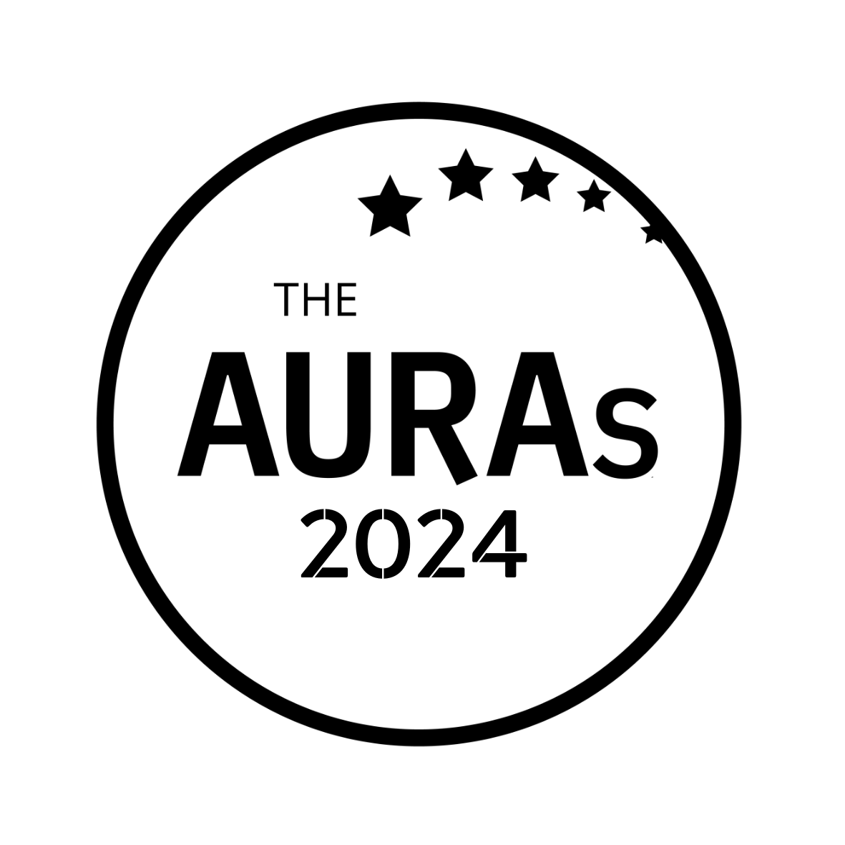

ROI AWARD (LARGER BUDGET) ENTRY FORM

Award Criteria
This award recognises a research project or initiative by a research team and/or their agency which demonstrated a significant commercial return from its initial investment of at least £15,000

Your name:

Your company:

Contact email:

If you are entering with a research agency please let us know who they are

Name of agency

Contact at agency (email)

Important Stuff
We don’t have an upper or lower word limit on this.

You DO NOT have to share commercial data if you don’t want to. A broad indication of the commercial return will be sufficient. The entry may be in regards to a research project or some other action or investment made by a research team which generated commercial benefits in excess of its investment

YOUR ENTRY

Please submit this form by email to awards@aura.org.uk by 1800hrs on Wednesday 15th May 2024

CONDITIONS OF ENTRY & USEFUL INFO

- You may jointly enter with a research agency but the entry must be submitted by an AURA member
- A member company may make more than one submission. Each entry should be submitted on a separate form
- You must be an AURA member at the time nominations close for your entry to be eligible
- Nominations close on Wednesday 15th May 2024. Shortlisted entries will be contacted no later than 10th June 2024
- Entries will be judged by a panel of AURA Directors. You will not be asked to present your case study
- The winner will be announced at the AURAs on 25th July 2024, which will be held at the Kia Oval, London

With thanks to LoveBrands for their support for this award

