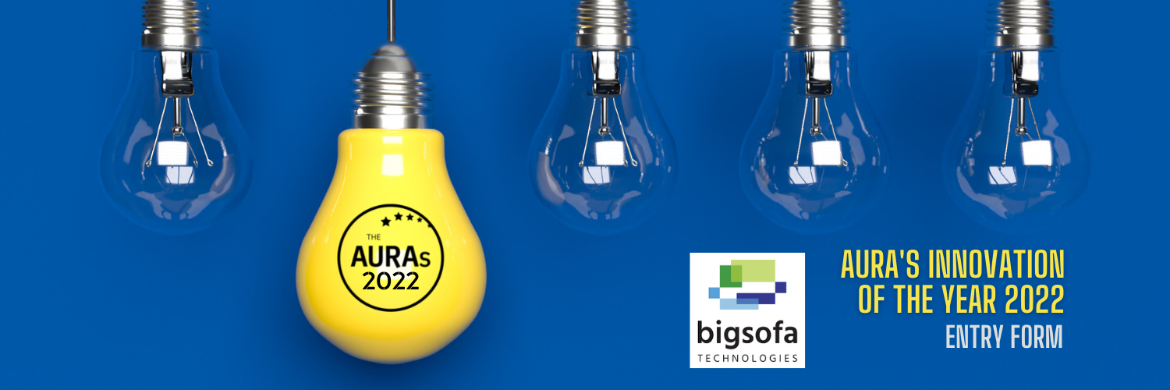

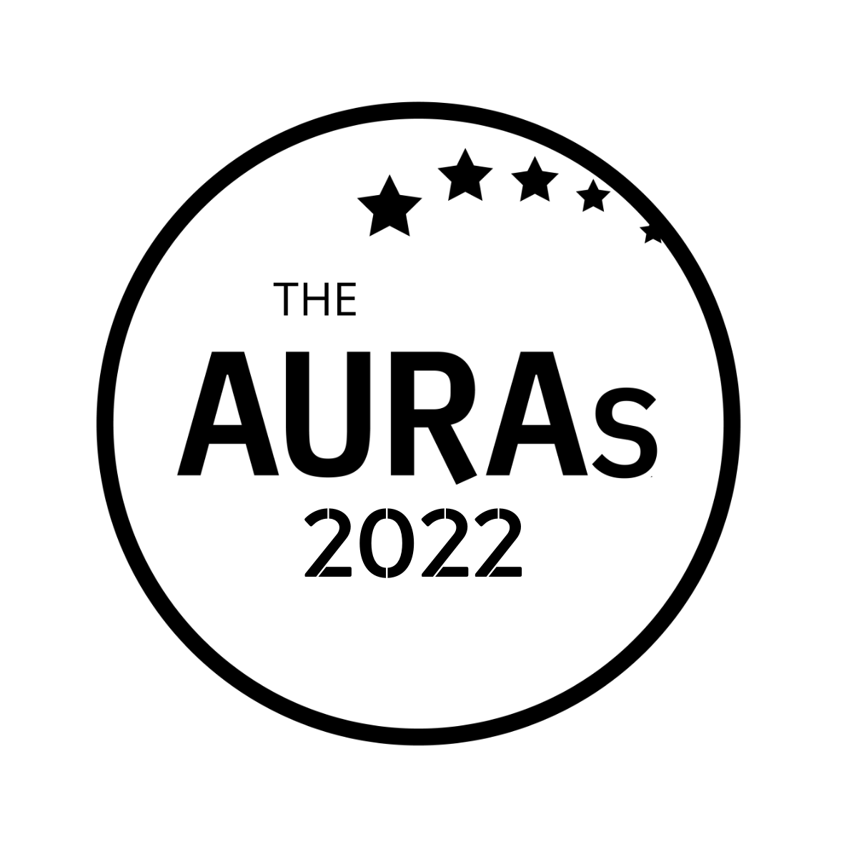

INNOVATION OF THE YEAR ENTRY FORM

YOUR NAME:

YOUR COMPANY:

Your email address (so we can update you on the progress of your nomination)

Please email this form to marketing@aura.org.uk by 1800hrs on 13th May 2022

Give us a brief description of your innovation. In particular we’re keen to hear what makes it different and its practical applications. You can augment your submission with presentations/demo links if you want to but please keep them as short and descriptive as possible!

- Tell us about your innovation [up to 250 words]

- What would you say are the principal benefits of this innovation compared with established methods?

- Are there any particular business questions or sectors that might find this innovation particularly useful?

KEY DATES

- Closing date for submissions is 1800hrs 13th May 2022. Any entries received after this date will not be considered
- Shortlisted finalists will be contacted by AURA on or before 2nd June 2022 and announced publicly w/c 6th June 2022
- The shortlisted finalists will compete for the award at a live AURA online event on 29th June 2022
- The winner will be announced at the AURA Awards Dinner on the evening of 14th July 2022

Please email this form to marketing@aura.org.uk by 1800hrs on 13th May 2022

If you have any questions or want to chat through something before submitting, please contact Suzanne Lugthart – marketing@aura.org.uk

