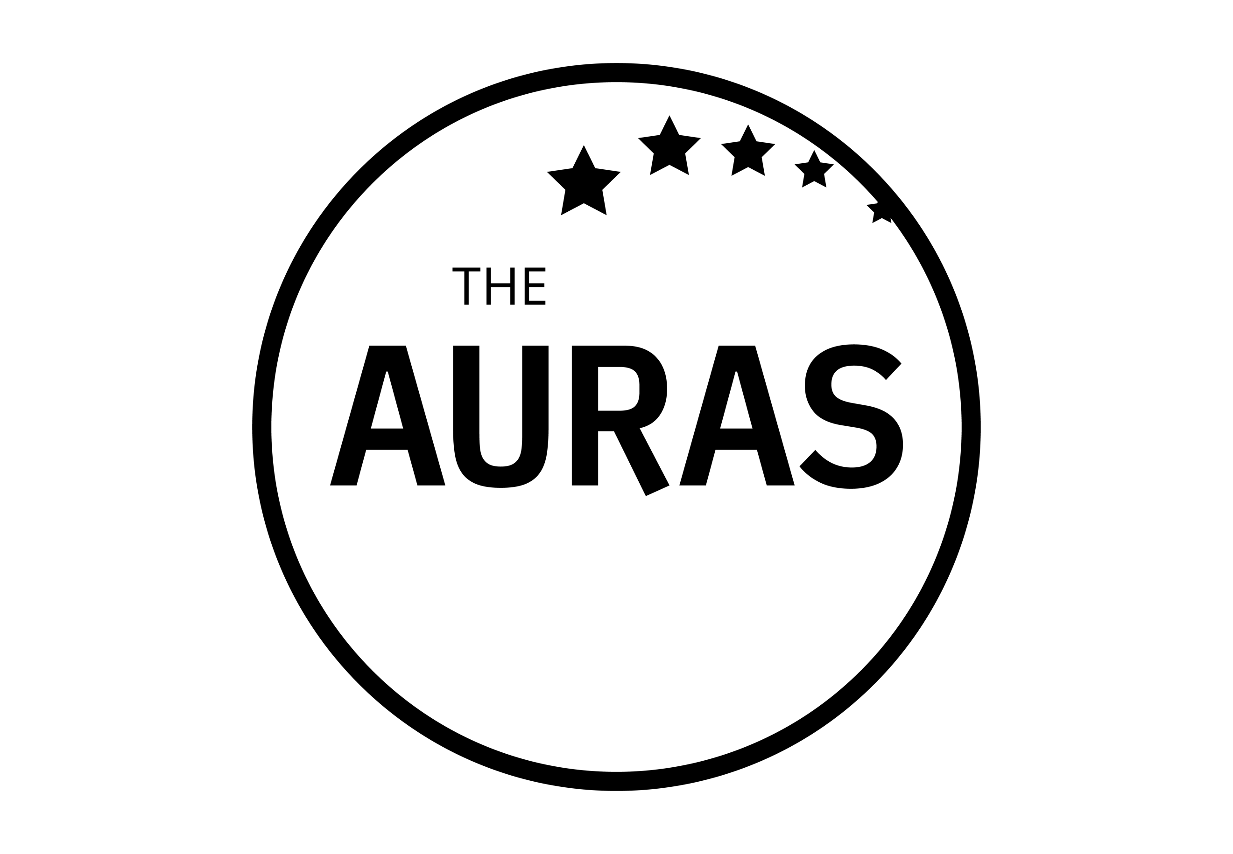

THE AURAs 2021: BEST CLIENTSIDE TEAM ENTRY FORM

This award recognises the quality, skills and impact AURA members have within their own organisations. It reflects on either the quality delivered in a single far reaching piece or a sustained body of work delivering of quality insights
.

Your name:

Your company:

Number of people in your team:

Please tell us why your team deserves to win this award. Wherever possible use measurable examples to demonstrate.

This is a wide ranging award and could include nominations based on but not limited to areas such as earning influence amongst stakeholders; team building and personal development; going above and beyond on a particular project or a longer term reflection of a body of work that has been built up over time; delivering insight faster, better, cheaper insights etc. Each submission should be endorsed by at least one stakeholder working within the nominee company, but you may supply up to three endorsements.

YOUR ENTRY (max 500 words)

SUPPORTING ENDORSEMENTS (minimum 1, maximum 3)

Name and job title of first endorser (required)

First endorsement (required)

Name and job title of 2nd endorser (optional)

Second endorsement (optional)

Name and job title of 3rd endorser (optional)

Third endorsement (optional)

Please submit this form to awards@aura.org.uk by 1800hrs on 31st May 2021

CONDITIONS OF ENTRY

- Only people working for companies that were members of AURA at the time of the AURA Awards announcement on 19th July 2021 are eligible to enter

- Each submission must not exceed 500 words (any additional wording will be discounted and not provided to the shortlisting panel) and must include at least one stakeholder endorsement

- Entries may reflect a single project or a body of work

- Submissions and all applicable information will be treated in confidence

- Case studies can reflect a single project or a body of work

KEY DATES

- Closing date for submissions is 1800hrs 31st May 2021. Any entries received after this date may not be considered

- Shortlisted entrants will be contacted by AURA publicly announced w/c 14th June 2021

- The shortlisted finalists and winner will be invited to the AURA Awards ceremony on 19th July where the winner will be announced

GOOD LUCK!

