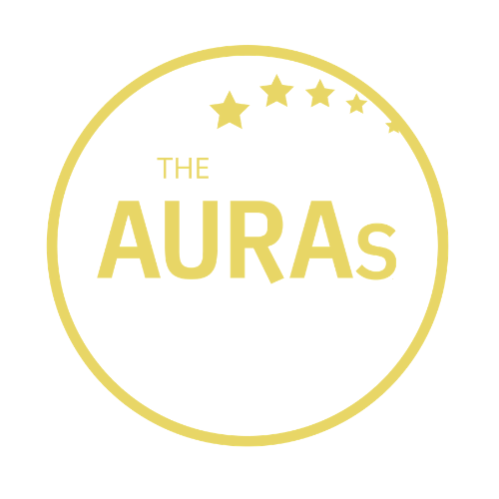

THE AURAs 2021
HERO AWARD NOMINATION

I’d like to nominate for an AURA Hero Award

And this is why they are worthy of this award:

Your name (optional):

Your email address
(if you want us to update you on the progress of your nomination)

Please email this form to awards@aura.org.uk by 1800hrs on 31st May 2021

THE SMALL PRINT

- Anyone working in the industry can nominate someone for an AURA Hero Award
- The nominees must work or have worked in the research industry. They may come from agencies and clientside, AURA members and non AURA members

KEY DATES

- Closing date for submissions is 1800hrs 31st May 2021. Any entries received after this date will not be considered
- Shortlisted finalists will be contacted by AURA on or before 14th June 2021 and invited to the AURA Awards Dinner
- The winner will be announced at the AURA Awards Dinner on the evening of 19th July 2021

GOOD LUCK!

