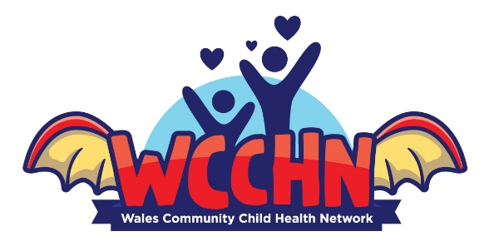

2nd Annual Conference
Friday 24th April 2026
Wrexham Medical Institute
1015-1025 Registration and coffee

1025-1030 Welcome and Introduction to the Day
– Dr Lizzy Nickerson

1030-1115 Neurodevelopment: what else could it be? Genetic Mimics
- Dr Carrie Pottinger
1115-1200 Neurodevelopment: The voice of the service user
- Ms Rebecca Jolliffe
1200-1245 Early Developmental Trauma
- Dr James Barker

1245-1345 LUNCH

1345-1455 ND service delivery update
-All Health Boards (10mins each)
1455-1515 Q+A and Open Discussion

1515-1530 REFRESHMENT BREAK

1530- 1615 Safeguarding: FII/Perplexing Presentations
– Dr Lizzy Nickerson
1615-1655 WCCHN Workplan items- Sleep Guidance and Cerebral Palsy Annual Review Template
– Dr Ingrid Prosser and Dr Rachel Lindoewood
1655 Closing remarks

