False Health Information Risks

After completing the local Social Communication Pathway, 7-year-old Zain was shown to meet the criteria for a diagnosis of autism. You tell his parents of the outcome during a face-to-face appointment. They were expecting this diagnosis and have printed out the details of a service recommended to them by a relative in Pakistan. Their GP laughed at them when they asked him about it but they would like to know what you would recommend.

https://irmsc.com/the-importance-of-boosters-how-many-stem-cell-treatments-does-a-child-need/

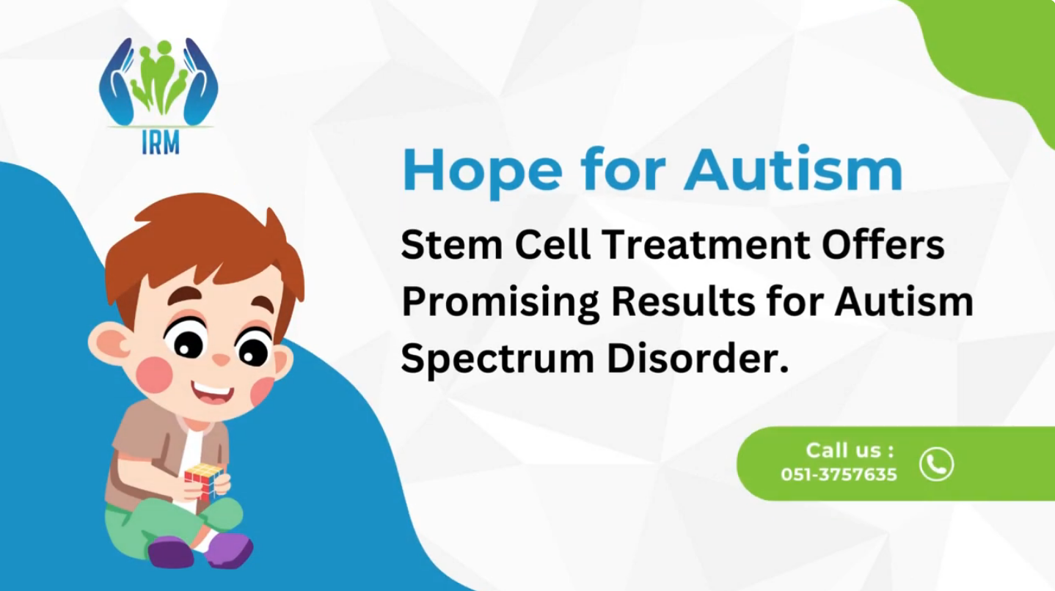
Screen shot from: https://youtu.be/LmnVYmVmInw [accessed 13th Feb 2026]

- Why might stem cell treatment be offered to autistic people in Pakistan?

- What might be the harm to Zain of undergoing this treatment?

- What might be the harm to Zain of his GPs response to this treatment?

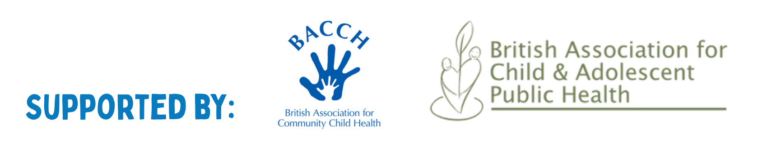
- How would you respond to Zain’s parents?

