Sudden unexpected death in childhood

You receive a crash call to the emergency Department at 07:15am . Information from the paramedics on route is that they are performing CPR on a 6 week old baby who has been found not breathing by their mother.

The baby arrives at the emergency department. There are no signs of life. CPR continues but after 35 minutes of effective CPR with no signs of life, a collective decision is made to withdraw any further active treatment and the baby is pronounced dead. Information from the paramedics, parents and police who attended is that the mother had fallen asleep on the sofa with the baby on her chest after a bottle feed at about 05:00am.
As a senior trainee the consultant on-call asks you to complete the necessary paperwork, send a report to the paediatric pathologist, copied to the coroners officer and attend both the case review and the CDOP as part of your training. At the CDOP panel there are two other infant deaths where inappropriate sleeping positions are contributory factors to the infant deaths. It is decided that there should be a review of the information provided to parents about sudden infant death syndrome both during pregnancy and after delivery.
Working with your local Public Health Department you volunteer to help with this review. 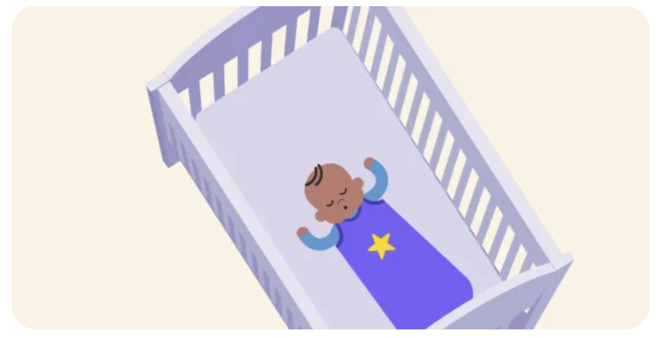
Image : Lullaby Trust

- What support should be provided to parents and staff?
- How might you look at trends? What data might be available locally and across the UK?
- What is the evidence about the contribution of sleeping position to sudden unexpected infant death?
- What processes are in place to inform the correct people about the findings from a CDOP meeting?
- What information can be given to parents following a CDOP meeting?
- Is the information available appropriate and accessible for all groups in the community?
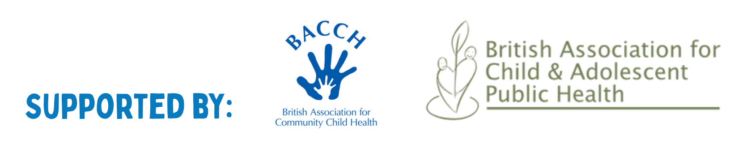
- Which websites have good evidence- based advice and could be recommended?

