Vaping

A 15 year old boy attends your clinic for a review of his ADHD medication. He tells you that he is unable to sleep and feels worried about his upcoming exams.

You perform a HEADSSS assessment and he tells you that he is vaping. He is not smoking or taking any other recreational drugs. He says he does this “all the time” and cannot study without vaping. He is worried about not being able to vape at school during his exams and says he cannot concentrate without it.

He often stays up late trying to revise, and will vape out of his bedroom window. He does not fall asleep until 3 am, and then needs to get up in the morning for school.

He buys his vapes from a corner shop but also tells you that he takes some of his parents e-liquid without their knowledge or shares vapes with friends when he runs out of money.
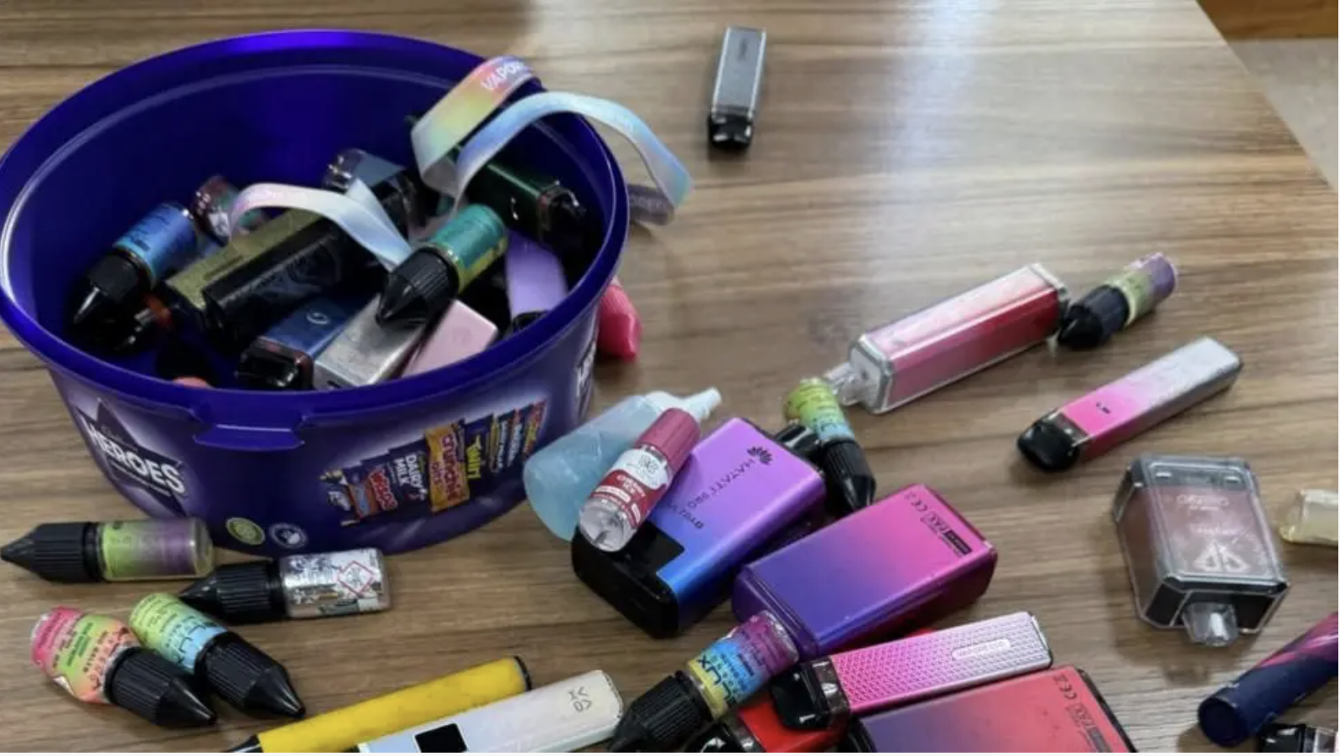
Image: BBC News

- What further questions could you ask to gather more information about his nicotine intake?

- What health advice can you give about vaping?

- Is there any support you can signpost him to ?


- What should you do about his disclosure that a corner shop is selling him vapes?

