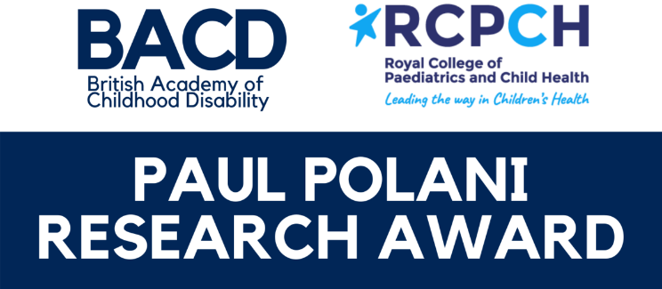

Past award winners

Breathe-Easy: a pilot study to examine the acceptability and feasibility of a novel night-time postural management night-time intervention (PMN-TI) to improve respiratory health of children with complex neuro-disability (2020)
Dr Sarah Crombie, Dr Jessica Baskerville, Dr Diane Sellers, Dr Akshat Kapur, Professor Stephen Bremner, Dr Christopher Morris.
This award was co-funded by the RCPCH and the Chartered Society of Physiotherapists Charitable Trust (CSPCT).

Non-invasive assessment of anaemia in children with neurodisability attending community paediatric clinics: A feasibility study (2019)
Dr Richard Lee-Kelland, Dr Steve Jones, Dr Clare Sheahan, Professor Pete Blair, Dr Jenny Ingram, Dr Fiona Finlay

Modern illness or a thing of the past? Surveillance study of childhood/adolescent Syndenham's chorea in the UK and the Republic of Ireland (2018)
Dr Tamsin Newlove-Delgado, Dr Oana Mitrofan, Dr Eva Woodling, Dr Michael Morton, Dr Ming Lim, Andrew Samuel, Nadine Mushet, Prof Stuart Logan

How Much Does it Cost the NHS to Assess a Child for Possible Autism? (2016)
Dr Ian Male, Dr William Farr, Emma Gowling, Dr Stephen Bremner, Prof Heather Gage and Aaron Gain

The Eating and Drinking Ability Classification System for cerebral palsy: a study of stability and associations with growth over time (2015)
Dr Diane Sellers, Dr Liz Bryant, Alison Hunter, Dr Vivienne Campbell and Sam Weddell

Identification of behavioural risk markers for Challenging Behaviour in very young children with intellectual disabilities (2013)
Dr Dawn Adams, Prof. Chris Oliver, Louise Handley, Associate Prof. Doug Simkiss

The use of taping to improve thumb and wrist posture and hand use in infants with non-progressive brain lesions affecting hand function (2012)
Dr Anna Basu, Dr Jill Kisler
Creation and validation of a tool for identifying children with functional visual impairments in children with hemiplegia (2011)
Dr Melissa Gladstone

Sleep in Children with Severe Cerebral Palsy-Objective Measurement of the Impact of Botulinum Toxin Hip Injections (2010)
Dr Charlie Fairhurst, Suzie Turner, Jane Orgill, Claire Lundy, Mat Blackshaw, Dr Paul Gringras

Respiratory function in children with severe motor disorders using night-time postural equipment (2009)
Dr Cathy Hill, Dr Kathryn Padoa, Penny Allen, Pam Shults, Dr Romola Bucks

Measuring the efficacy of computer communication intervention for children with cerebral palsy (2008)
Dr Jeremy Parr, Katie Price

Establishing the Lifestyle Assessment Questionnaire, a measure of participation (2007)
Dr Helen McConachie, EC Jessen and Rob Forsyth

Predicting the development of intelligible speech by children with cerebral palsy: a pilot study (2007)
Dr Lindsay Pennington, Dr Mark Pearce, Prof Allan Colver & Dr Mary Gibson

