

Spotlight on Safety Story

|  |  |
| --- | --- |
| **Title of Spotlight on Safety Story:**  **Name & Role of person submitting:**  **Acknowledgement:**  **Workplace:**  **Email / Tel:**  **Do you wish your name / unit to be removed before circulation to BAPM members?:** | |
| **Situation** |  |
| **Background** |  |

|  |  |
| --- | --- |
| **Assessment** |  |

|  |  |
| --- | --- |
| **Recommendations** |  |

Reference

1. **Migration of Central Venous Catheters in Neonates: A Radiographic Assessment**

[Ruby Gupta](https://pubmed.ncbi.nlm.nih.gov/?term=Gupta+R&cauthor_id=26731179)[1](https://pubmed.ncbi.nlm.nih.gov/26731179/#full-view-affiliation-1), [Amy L Drendel](https://pubmed.ncbi.nlm.nih.gov/?term=Drendel+AL&cauthor_id=26731179)[2](https://pubmed.ncbi.nlm.nih.gov/26731179/#full-view-affiliation-2), [Raymond G Hoffmann](https://pubmed.ncbi.nlm.nih.gov/?term=Hoffmann+RG&cauthor_id=26731179)[3](https://pubmed.ncbi.nlm.nih.gov/26731179/#full-view-affiliation-3), [Carla V Quijano](https://pubmed.ncbi.nlm.nih.gov/?term=Quijano+CV&cauthor_id=26731179)[4](https://pubmed.ncbi.nlm.nih.gov/26731179/#full-view-affiliation-4), [Michael R Uhing](https://pubmed.ncbi.nlm.nih.gov/?term=Uhing+MR&cauthor_id=26731179)[1](https://pubmed.ncbi.nlm.nih.gov/26731179/#full-view-affiliation-1)

2016 May;33(6):600-4.

DOI: 10.1055/s-0035-1570341. Epub 2016 Jan 5.

1. **Peripherally inserted central cathether migration in neonates: Incidence, timing and risk factors**C Acun 1, A Baker 2, L S Brown 3, K A Iglesia 4, J Sisman 5, Neonatal Perinatal Med ,2021;14(3):411-417. DOI: 10.3233/NPM-200684.

**Images:**

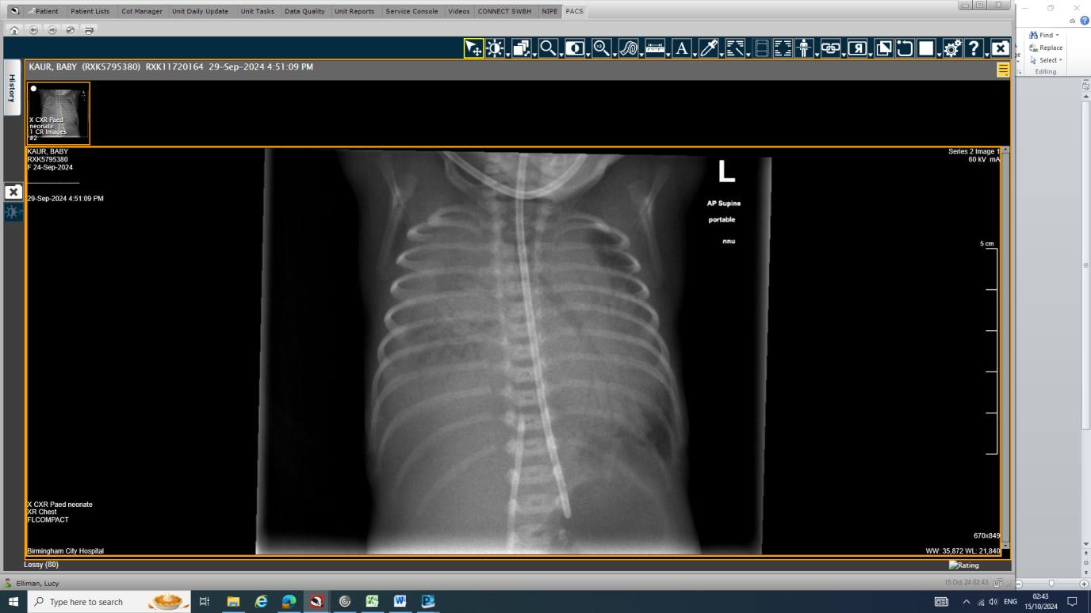

*Figure 2 – Day 5-CXR showing diffuse right sided opacity with enlarged Cardiac silhouette*

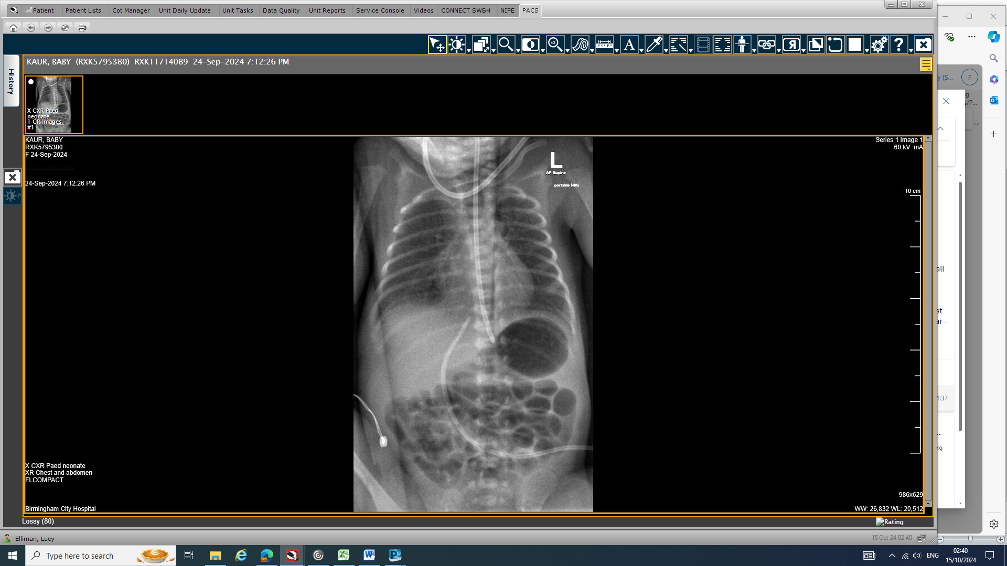

*Figure 1 – Day 1-Chest and abdominal x-ray confirming UVC position at T9-T10*

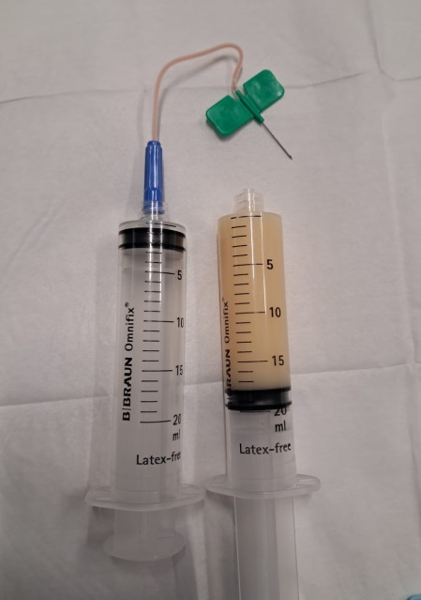

Figure 3- Image of echocardiogram on apical view demonstrating large pericardial effusion causing tamponade

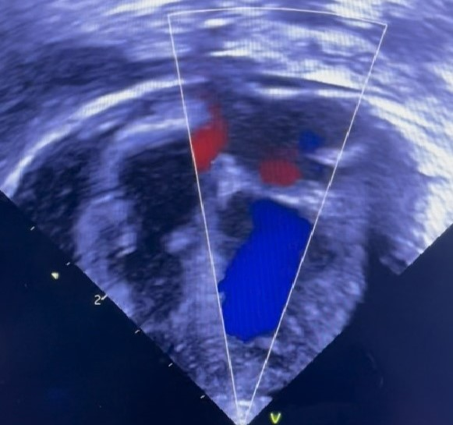

Needle aspiration of the cardiac tamponade

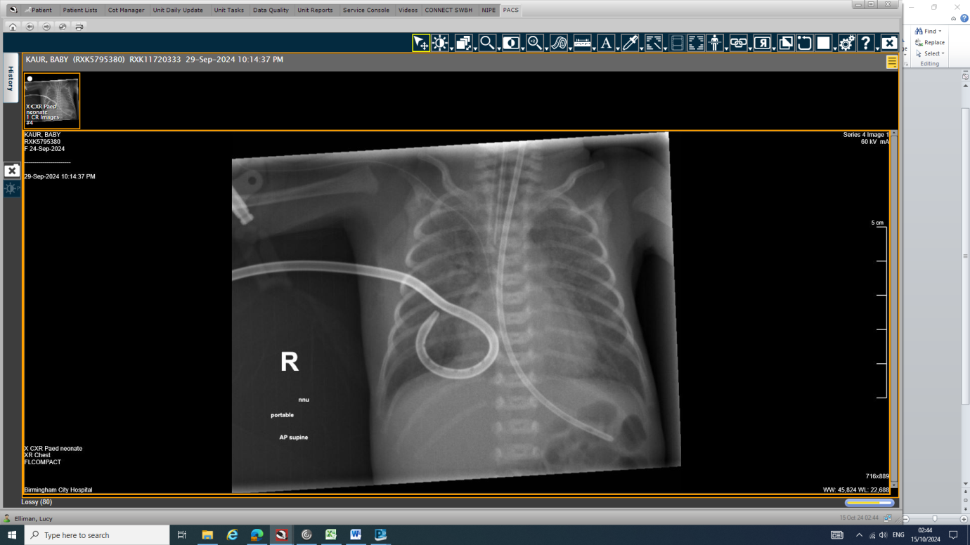

*Figure 4 – CXR demonstrating position of ET tube at T4-T5 just above the carina, right-sided pigtail chest drain, and longline with tip in R atrium. Cardiac silhouette is normal after pericardial aspiration and R side pleural effusion is cleared*

Return to [bapm@rcpch.ac.uk](mailto:bapm@rcpch.ac.uk)