
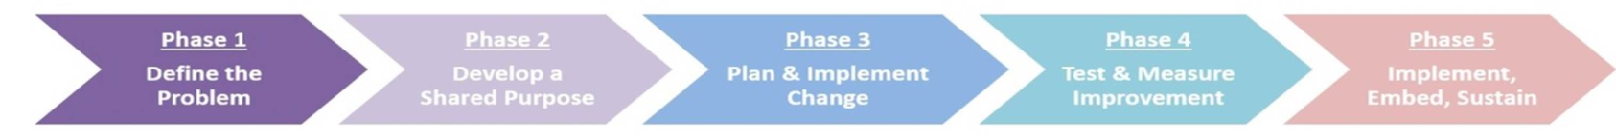
QI story, mapped to BAPM NSQI standards
Title of QI project:
Name & Role:
Workplace:
Tel / Email:

(Please try and keep the information to bullet points within the boxes)
Summary of project
(for use on website – max 60 words.)
Identifying the need for QI:
What were the triggers?
(Adverse Events, Guidelines, Service Standards, Bench-marking exercise, Staff/parent feedback, other)
NSQI 1 – Evidence Based Care
NSQI 4 – Audit and Benchmarking
NSQI 5 - Patient Safety
How did you initiate the project, identify the purpose, establish the baseline and create momentum?
(Who were your stakeholders/MDT?
How did you establish the baseline for your intervention?
Did you apply for any funding, if so, who from?)
NSQI 2 – Team working & communication
NSQI 4 – Audit and Benchmarking

(Did you coproduce the intervention with families?)
NSQI 3 – Parental partnership in care
What did you do?
(What worked and what was unsuccessful?)
NSQI 6 – Quality Improvement

How did you evaluate the progress of your project?
(Did you build live evaluation in to see whether the intervention was having an impact? Did this then allow you to make iterations based on data? Did you have to change direction following on from data?)
NSQI 4 – Audit and Benchmarking

Max 2 figures can be included

Is your intervention now embedded as normal practice on your unit/network?
(Is your project intervention still in place now the project has finished? How do you ensure the sustainability of the project?)
NSQI 6 – Quality Improvement

What challenges and barriers did you face specific to your project?
What 3 points of advice would you give others about to embark upon this project in their unit?

