Data Collection guide

- Total number of babies – this should be the total number of babies DISCHARGED from the maternity ward on this day. Babies’ charts should be reviewed only once, on the day of discharge
  - Only a baby’s first admission should be included, any subsequent readmissions should be excluded

- Number of babies that needed NEWTT2 – this is the number of babies who met one or more of the criteria for requiring observation on a NEWTT2 chart (as per Appendix 1 of the BAPM Deterioration of the Newborn Guideline). These babies should be divided into those who were correctly observed using the chart and those who were missed.

- Number of babies that didn’t need NEWTT2 – some of these babies may have been observed on a NEWTT2 chart despite not meeting any of the inclusion criteria and this number should be documented here

- Was the chart filled in correctly? - For the purposes of this audit a chart should be counted as having been filled in correctly if FULL SETS of observations were recorded at the CORRECT TIMES and a correct TOTAL SCORE was calculated. Please choose ‘missed obs’ if individual observations were missed within a set, for example if there was no score for temperature or parental concern. ‘Wrong timings’ means that whole sets of observations were late or were missed altogether, and ‘wrong score’ is where the score has been added up incorrectly. Some charts may be incorrect in more than one way and so multiple options can be selected.

- How many episodes of escalation were there? – we are counting episodes of escalation as some babies may have had more than one escalation event and these should be analysed separately

- What was the reason for escalation? – the last option here is to be chosen when the infant’s score did not reach the threshold for escalation but there was sufficient healthcare professional concern that escalation occurred

- Was the escalation carried out correctly? – please answer yes if the escalation was to the correct person, the review was requested within the correct time frame and occurred on time. If the escalation was not carried out correctly (to the wrong person or requested within the wrong time frame) then please choose ‘escalation incorrect’ or if the review did not happen within the expected time frame then please choose ‘late review’. If the review was later than the escalation pathway requires because the wrong time frame was requested initially then please just mark ‘wrong time frame requested’.

We anticipate that those reviewing notes will create a tally chart as they review each set of notes, placing marks next to the most appropriate option for each question.

Below is an example of a chart which has been completed for the first day of the week.

It shows that on Monday 20/10/25:
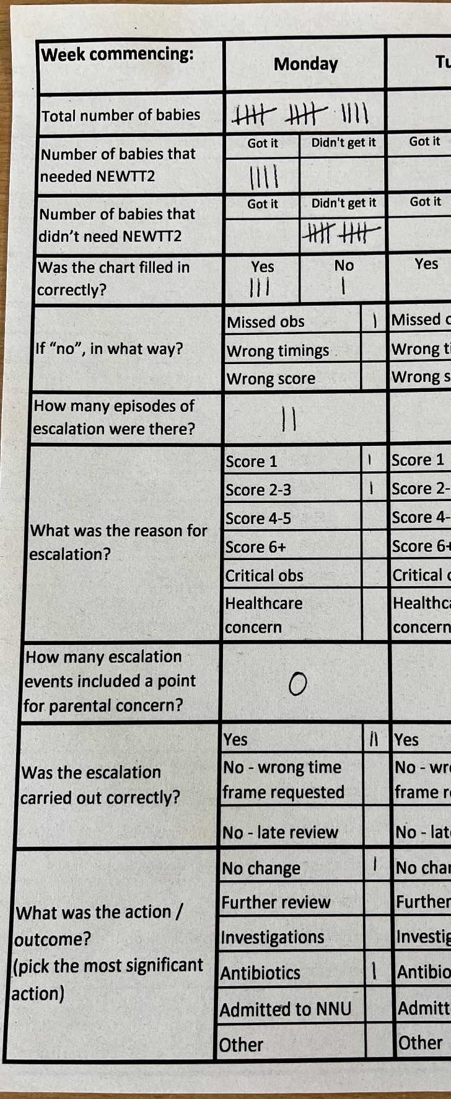
- 14 babies were discharged home from the postnatal ward

- 4 of these babies were eligible for NEWTT2 monitoring and all 4 received this monitoring

- No babies who did not require a NEWTT2 chart were monitored on one

- 3 charts were completed correctly, 1 was not

- The incorrect chart had some observations missing – in this case no temperature had been recorded for one of the sets of observations. Please note that this chart could also have been wrong in other ways, so it would have been possible to have had a 1 next to ‘wrong timings’ and/or ‘wrong score’ as well.

- There were 2 episodes of escalation – these may have been for the same baby or for different babies

- The reasons for the escalations were a score of 1 and a score of 2-3

- None of these escalations included a point for parental concern

- The escalations were both carried out correctly.

- The result of one escalation was no change in the baby’s care and for the other escalation the baby was commenced on antibiotics

