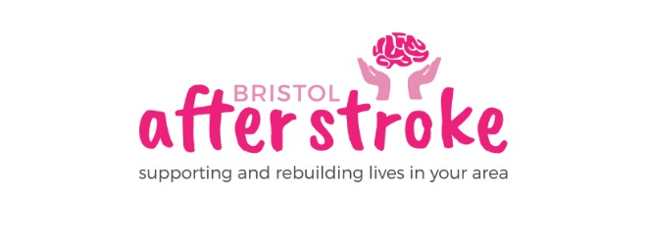
9th March 2026

Dear Applicant
Thank you for enquiring about the Stroke Support Coordinator post.

Enclosed is:
- A job description
- An application form
- An equalities monitoring form

For any further information you might require about Bristol After Stroke or the application process, please see our www.bristolafterstroke.org.uk or call the office on 0117 964 7657.

If you would like an informal discussion about the post, please call Gemma Holden on the numbers below.

The closing date for applications is Wednesday 25th March at 5pm. Please return your application and equalities monitoring form by email or post.

Email : office@bristolafterstroke.org.uk
Post: Bristol After Stroke, The Gatehouse Centre, Hareclive Rd, Bristol, BS13 9JN

Please note interviews will be held at our office on Wednesday 1st April.

Thank you again for your enquiry. We look forward to receiving your application.

Yours sincerely
Gemma Holden
Gemma Holden
Operations Manager
Office: 0117 9647657
Mobile: 07483 045720

