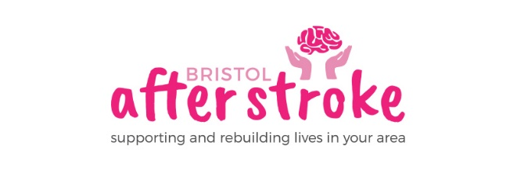
1st February 2022

Dear Applicant
Thank you for enquiring about the Stroke Key Worker post.

Enclosed is:
- A job description
- An application form
- An equalities monitoring form

For any further information you might require about Bristol After Stroke or the application process, please see our www.bristolafterstroke.org.uk or call the office on 0117 964 7657.

If you would like an informal discussion about the post, please call Gemma Holden on the numbers below.

The closing date for applications is Monday 21st February. Please return your application and equalities monitoring form by email or post.

Email : office@bristolafterstroke.org.uk
Post: Bristol After Stroke, The Gatehouse Centre, Hareclive Rd, Bristol, BS13 9JN

Please note provisional date for interviews is Wednesday 2nd March.

Thank you again for your enquiry. We look forward to receiving your application.

Yours sincerely
Gemma Holden
Gemma Holden
Operations Manager
Office: 0117 9647657
Mobile: 07483 045720

