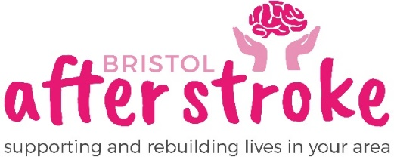

Job Description : Marketing Officer

Hours per week 12 Hours.

Salary £27,859 pro rata

Location Office: The Gatehouse Centre, Hareclive Rd, Hartcliffe, BS13 9JN.
Accountable to Chief Executive

Job summary Lead Bristol After Stroke’s marketing activities

Context Part time
Six month probationary period.

Main duties
- Contribute towards the development and maintenance of the web site, charitable publications and materials.
- To support the Fundraising Officer to deliver a broad range of income generation activities through marketing promotion.
- To work effectively with all people, developing productive relationships with colleagues, volunteers, external partners and the Board of Trustees.
- To manage the creation, and use of social media channels with support from key office staff.
- Create marketing materials using photography and videography skills
- Create compelling website and newsletter content
- Research and write engaging press releases to positively promote Bristol After Stroke’s latest news.
- Help to develop impactful stories.
- Utilise National and Local campaigns to celebrate the work of the charity and generate income.
- Deliver marketing campaign materials and create design concepts using software such as Canva, Publisher etc.
- Work with the Fundraising Officer to create a marketing strategy to increase legacy donations.
- To support the work of volunteers and community members in generating income activities for the charity through marketing promotion.
- Maximise the potential of the charity’s database for communications purposes.
- Contribute to monitoring, reporting and evaluating of how marketing has impacted fundraising activities.
- To work to the Marketing Code of Practice and operate within those guidelines.
- Work closely with the Fundraising Officer and Volunteer Co-ordinator.
- To represent the organisation as required.

The job description may be subject to review and negotiated change. It is intended to contain sufficient flexibility to incorporate the special interest of the post holder and development of the role.
Person Specification
Qualifications:
- Be educated to degree level or equivalent Desirable

Experience:
- Experience in a marketing role. E
- Experience of supporting the planning and delivering or projects or campaigns. E
- Experience of writing and engaging audiences on social media to support fundraising and communication. E
- Experience of working in the voluntary charitable sector. D

Skills and Knowledge: all Essential

- Ability to write engaging copy and content for newsletters, social media posts, blogs, letters and email.
- Excellent written and verbal communication skills
- Experience using a CRM system
- Experience of all PR channels and the ability to create engaging press releases
- Proven IT skills with design packages such as Publisher, Canva, InDesign and Photoshop
- Able to work to detail and to manage multiple projects.
- A track record of using insight to inform evidence-based decision making.
- A team player with the desire to work collaboratively

Personal skills: all Essential
- Strong team player but with ability to work under own initiative
- Excellent interpersonal skills
- A flexible and adaptable approach
- Innovative and enthusiastic
- Ability to work collaboratively
- Access to transport across Bristol and South Gloucestershire

E = Essential D = Desirable

