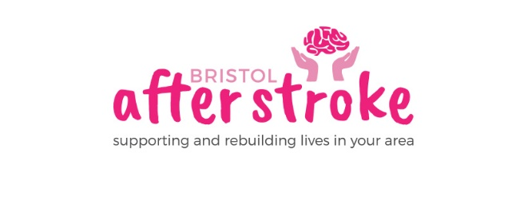
19th June 2023

Dear Applicant
Thank you for enquiring about the Marketing Officer Post .

Enclosed is:
- A job description
- An equalities monitoring form

For any further information you might require about Bristol After Stroke or the application process, please see our www.bristolafterstroke.org.uk or call the office on 0117 964 7657.

If you would like an informal discussion about the post, please call Rebecca Sheehy CEO on the numbers below.

The closing date for applications is Monday July 10th at 9am. Please return your CV and equalities monitoring form by email or post.

Email : office@bristolafterstroke.org.uk
Post: Bristol After Stroke, The Gatehouse Centre, Hareclive Rd, Bristol, BS13 9JN

Please note provisional date for interviews is Thursday 20th July

Thank you again for your enquiry. We look forward to receiving your application.

Yours sincerely
Rebecca Sheehy
Rebecca Sheehy CEO

Office: 0117 9647657
Mobile: 07989747960

