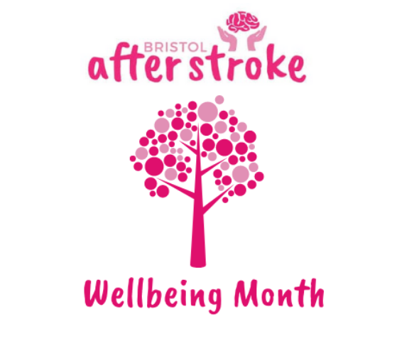

Wellbeing Day

  Date | Friday 25th October 2024
  Venue | Oatley Hall, St Monica Trust, Cote Lane, Bristol, BS9 3UN
  Time | 10am – 2.30pm
  Information Stands | 9am – 10am  Lunch Break

Time | Subject | Speaker
10am | Introduction | Mike Hill  Chair of Trustees | 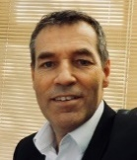
10.10am | Welcome – Exercise Taster |  | 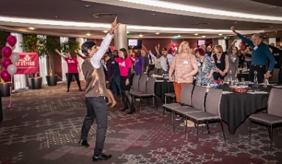
10.25am | Bristol After Stroke review | Rebecca Sheehy  Chief Executive | 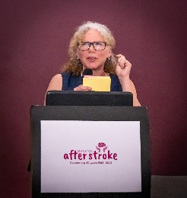
10.50am | Finding Your Feet after stroke | Lived Experience Pannel | 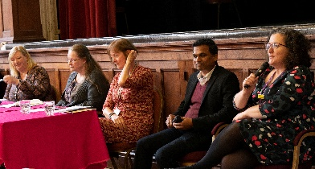
11.30am | Health Professional Q&A - living well after stroke | Therapists from Sirona  Everyone Active | 
 | Younger – looking forward to getting older | Alex Rotas – photographer  Dot – Runner with Lived Experience | 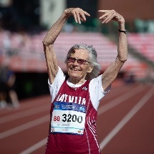
11.50am | Presentation of thanks | Rebecca Sheehy & Jenny Hollis | 
12.10am | Lunch |  | 
13.00pm | Update from Stroke HIT Lived Experience Group | Chair of LEG – Claire Angel | 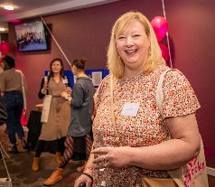
13.15pm | Creativity and recovery - how this helps | Sarah Woodward SLT and Hazel Hammond – Poet/ Artist | 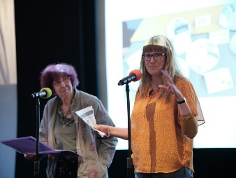
13.40pm | Music and recovery – How can music support rehabilitation | Laura Cook Music Therapist  Emma Richards  Sirona ICSS Stroke Lead | 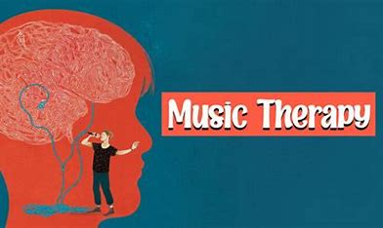
14.15/30pm | Summary & Close

