What is Counselling?
Counselling is a talking therapy. Talking to someone who is trained to listen can sometimes help.
A counsellor will give you space to talk about whatever is troubling you. They are not there to give advice.
Sharing your thoughts and feelings with someone who will not judge you, can help you come to terms with yourself and your personal situation.
Some people benefit from just a few sessions and, as a result, are more able to face up to their life after a stroke.
How can it Help after a Stroke?
There is a lot to come to terms with following a stroke. It is likely to have disrupted many aspects of your life.
It is common to feel anxious or low afterwards. Your counsellor will do their best to understand what you are going through. Our counsellors have stroke-specific training to help them.
Our service is person-centred. We aim to see you as a whole person and not just your stroke. We know everyone’s stroke is different.
How many Sessions can I have?
We are a small charity serving many people and a large geographic area.
We offer 6 sessions. Sometimes there is scope for more, but this is the most common number people have from us.
If you are living with aphasia and have post-stroke communication issues, we can offer you additional sessions.
“In comparison with other counselling I’ve had post stroke, BAS is by far the best and most understanding… I wouldn’t suggest a stroke survivor in Bristol try any other service”.

Quote from a counselling client, 2023
How much does it Cost?
Private sessions can cost £60 or more. Low-cost services in the area charge £25 per session. We need you to tell us what you can pay towards sessions:
Standard Rate | £20
Reduced Rate | £10
Paying more helps us reach people who can’t afford anything and would otherwise miss out on counselling.
If cost is an issue, please talk to us.
You can donate more if you wish. And there are other ways of giving back, for example, you might later want to do some volunteering with us.
Where will it take Place?
You can have sessions by telephone or video. This is probably the quickest way you will be seen
In future, we may be able to see you from a local venue – we will advise you if this is a feasible option.
If online sessions are not feasible, let us know and we will see if we can arrange a home visit instead.
To be seen in your home, you will need a private space away from others so that you cannot be overheard talking. You will also need to let others who live with you, know you are not to be disturbed you for a while. This will support you to feel free to talk to your counsellor about anything at all that is concerning you.
When can I Start?
We delivered over 320 counselling sessions to 68 people in 2023.
Telephone and video options allow us to offer counselling to more people.
Medical appointments and similar with other professionals can often take a top priority after a stroke.
When you first speak to one of our counsellors, they will explore with you if this is the best time for counselling.
They will talk to you to see if we’re the most appropriate service for you.

We offer a FREE initial meeting
with one of our counsellors.

What if I need to Cancel?
Counsellors cannot re-book their time easily, so you will be charged for late cancellations and missed sessions.
If you need to end (for any reason) you can still request counselling again in 12 months’ time.
If counselling doesn’t meet your expectations, you can end it.
How Long are Sessions?
Counselling sessions are 50 minutes. It’s useful to have an idea of what you want to talk to your counsellor about at each session.

All our counsellors are members of a professional body and work to a recognised ‘code of ethics’.
Some are counselling students in the advanced stages of training.

Call 0117 9647657
Email office@bristolafterstroke.org.uk

Want to know more?
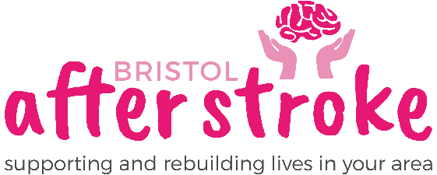

Counselling
Service
Telephone, video & in-person
Tuesday to Thursdays
9.00 am to 4.00pm

