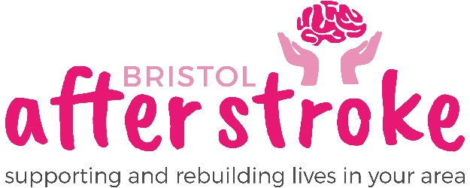

Volunteer Counsellor - Role Description

Purpose of Role
To provide one-to-one, short-term counselling to stroke-affected people (or occasionally their partners or family members). We start by offering just 6 sessions to help adjust to a life after stroke – sometimes this gets extended for ethical reasons but is generally no longer than 12 sessions (maximum).

Reporting to
You will report to, liaise with, and be supported by our Lead Counsellor who has been in their post over 9 years. They will make referrals to you from our waiting list and take account of your level of competence and experience.

Main Responsibilities
- provide 1:1 counselling to stroke affected people or immediate others
- keep records in line with BAS requirements and professional guidance
- engage in supervision provided by BAS (provided free) and with your own private supervisor e.g. in the approach you are training in or using
- maintain confidentiality within the context of team working in BAS
- attend training relevant to the role, beyond your initial induction
- assist in monitoring the impact of the counselling service.

Skills, Experience & Knowledge
- time-management skills e.g. for planning travel / caseload management
- assessment skills for monitoring client risk and suitability for counselling
- experience of team working and ability to liaise with other professionals
- knowledge of GDPR in relation to client material and organisational data
- understanding of how equality and diversity issues impact peoples’ lives
- some knowledge of the impact of stroke on individuals and their lives
- commitment to person-centred approach and its underlying values.
Personal Qualities
- confidence to navigate issues arising from working in a client’s home
- patience dealing with distressed (often medically vulnerable) people
- personal resilience for meeting people and their health-related trauma
- an enabling attitude to supporting with people with disabilities
- responsiveness to working in a team and receptivity to feedback
- a commitment to own personal development and growth.

Other Requirements
- Access to a personal computer and reliable broadband– essential
- Ability to travel extensively across Bristol and South Gloucestershire – if you are a driver, this may be helpful for time-management reasons.

We will also ask you to:
- complete an enhanced DBS disclosure.
- obtain two references – at least one from a professional e.g. a tutor

Bristol After Stroke
Updated by: Lead Counsellor, 08-July-2025

