NORFOLK SUZUKI VIOLIN CAMP 2025

Langley School, Loddon in South Norfolk from Friday 25th – Monday 28th July 2025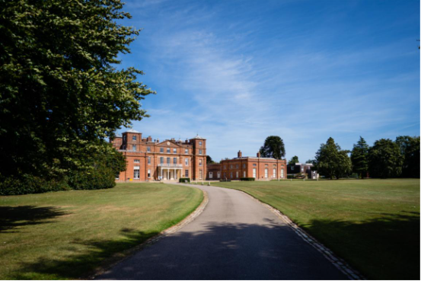

Come and learn from a great team of inspiring teachers and immerse yourselves in a variety of music making including Suzuki group lessons, Ensemble and orchestra playing, Folk session tunes, Improvisation, Individual lessons, Round Singing, Dalcroze, Drumming and Concerts.

**Accommodation options and facilities**

Choose between sleeping in a private family room in the main house or bring a tent to camp with use of the nearby facilities. ( There will only be space for two camper vans so if you wish to bring a van please let me know asap ) All your meals are provided in the dining hall and we will have access to the sports facilities for use in your free time including tennis courts, football pitches, indoor sports hall for basketball and beautiful grounds to explore. There will also be craft activities on offer for those who prefer a more relaxing breaktime.

Our lessons and workshopswill be housed in the school buildings which have ample class rooms, a ballroom for concerts and larger groups, and plenty of communal spaces for gathering in between classes. There are extensive grounds with areas of woodland to explore.

**The Timetable**

Each student will be given a timetable providing a variety of musical activities tailored to their age and level. This will include a Suzuki Group lesson and an individual lesson and at least two musicianship classes ( improv, drumming, folk, ensemble, orchestra , Dalcroze). The course is relatively small which means that we build the course around the students, ensuring a personalized experience! We can accommodate pre-Twinkle to book 6

Parents who are having violin lessons themselves are also welcome to apply as participants and any non- Suzuki siblings who play cello or viola are welcome to apply as participants and will be given a reduced timetable. As well as the regular daily timetable there will be concerts, play togethers, round singing, a folk session ( tunes provided in advance so everyone can learn as many as they want to and join in) and lots of fun to be had in the sports hall or on the football pitch and tennis courts or by enjoying a relaxing walk in the grounds.

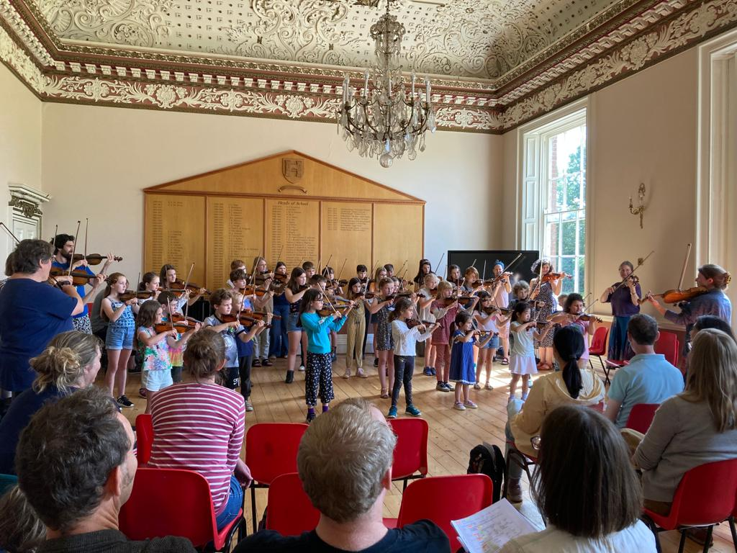

A play together in ballroom at Langley School- Norfolk Suzuki violin Camp - 2023

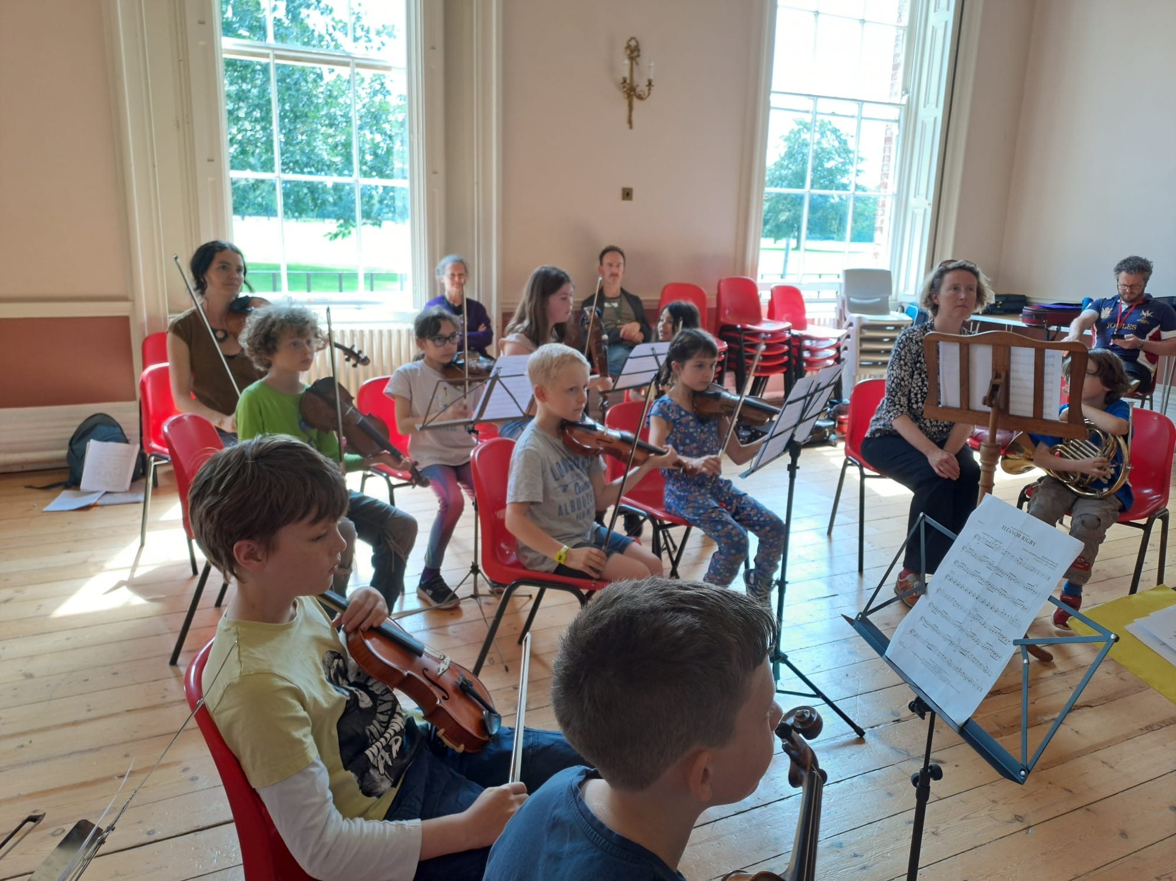

Everyone loves Hannah’s orchestra – but watch out …..she might make you play Etude!

**The Teachers**

This year we are very fortunate to have Hannah Biss, Rick O’Connor, Cara Vella, Ruth Furniss, Zina Zelter and Rosie Toll. They are all highly experienced Suzuki Violin teachers and musicians, who particularly share the most important quality of kindness. Love is deep with these wonderful people!

We are also extremely fortunate to welcome back our accompanist and improvisation/folk specialist Adrian Lever, and brilliant percussionist Blake Harrison who will be back teaching African drumming as part of our musicianship programme.

**We have an income based sliding scale** of fees to make the course affordable for all. The school charge the same for boarding house beds and camping, so the indoor beds will be assigned on a first come first served basis. We have limited spaces so please don’t bring extra non-playing adults or children unless absolutely necessary. If you have a medical reason why you can’t camp please state it on the form. Please email Rosie Toll on [rosiefiddlefaery@hotmail.com](mailto:rosiefiddlefaery@hotmail.com) to receive the application form and details of the sliding scale fee structure.

We are a Suzuki Summer School and therefore require participants to be current members of the BSMA. Please contact the office on [info@britishsuzuki.com](mailto:info@britishsuzuki.com) for membership enquiries.

Improvising with Rosie