Title and Aim | Holistic approach to Winter Health  Aim:  - To identify issues affecting self-care  - To develop strategies to enable self-care (includes Winter Season impact)  - To inform the health creators on diabetes symptoms and treatment  - Create a trusted environment (being heard and respected)
Description | South Asian women (Health Creators) worked on three health topics: self-care, medication management and diabetes. This was a small group consisting of three Health Creators who shared their stories to build an understanding of their health and health needs. Barriers were identified which prevented good health management. This further developed trusting and supporting relationships and allowed the participants to reflect on their own personal health.  An initial informal ‘chai session’ was held in a local venue to introduce the project to the group led by the PM. Ideas were discussed for the project themes and the 3 topics were selected by the VCSE lead. The session was interactive and personal, and led to a rapport being developed between the PM and the VCSE Lead and the PM and the group.  The second session was with the Health Creators co-led by the VCSE lead and PM and the women shared their stories opening and with confidence in a space that allowed them to be listened to and where the facilitators could respond with suggestions and ideas )truth-telling). The space allowed the VCSE lead to delve deeper – important! Women then shared their learning to the bigger group and it was heart-warming for the VCSE lead to see one of her ‘older’ ladies gain the confidence to openly discuss her needs and sharing what she had learnt regarding management of her diabetes (reciprocity).  Led by the facilitator, the discussions led to actions and ideas to improve their well-being; including the creation of three flyers on diabetes, self-care and self -medication that are culturally appropriate for the South Asian women.  During the session, one of the group participants who was interested in developing her knowledge and skills was given the role of facilitating discussions and producing resources. This young lady, later used her experience to obtain a full-time employed role.  “working on the winter health project helped me gain more insight into the issues South Asian women feel in regards to their health and the ways in which they try to overcome their problems. It helped me build up my confidence to speak to a group of people who I’m not usually used to speaking to about these topics. I’ve also developed my skills in using Canva and creating the leaflets required for this project. All of these skills and experience I have gained from being a facilitator for the winter health project I used to answer questions in my interview.”  – Health Creator  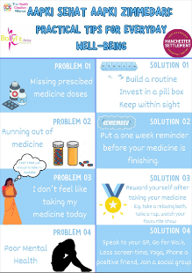  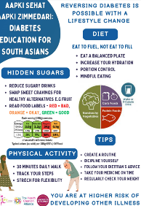  This project very much identified peoples’ strengths; Saira becoming a facilitator and producing resources. Sultana learning about diabetes and sharing her knowledge and the VCSE Lead recognising that there is quality in minimal numbers. It was easier to self-organise with a smaller group and thus, they spent a lot of time working together and now feel confident that they can develop projects using the framework.  The 3C;s and 6 features all developed in this project and the PM was thanked for her support.
Outcomes – | - Increased knowledge on topic areas  - Health Creators developed confidence  - Health Creator confident to talk to group regarding health issue and learning from the project  - The VCSE Lead and group enjoyed the project and provided affirmation.  - Resources produced with tips and information – new skill learnt  - Unexpected outcome – Group participant obtained full-time employment  - Health inequalities – women took ownership of their health

