Name: | Allan Mandindi and Rita Salika
Organisation: | Malawi Heritage U.K.

Title:  Aims: | Diabetes - To engage our community and our volunteers to raise awareness of the effects and symptoms of diabetes  - To raise awareness of diabetes in the community  - To develop our volunteers to become Health Creators
Description | Group delivered a diabetes themed project via 2 leads and 5 Health creators.  A Wattsapp forum was created to share project information with everyone who engaged with Malawi Heritage U.K. (above 100 people!) and was also used to manage the project i.e. allocated tasks and responsibilities.  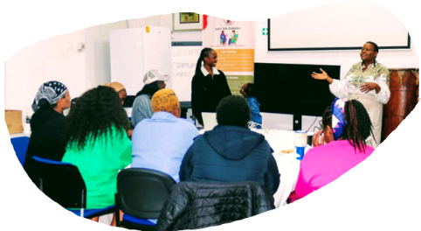  Discovered that most participants were unaware about diabetes, especially the difference between Type 1 and Type 2. Connections were made with the wider community (mainly African Caribbean community) via drop-in sessions held at the Malawi Heritage Centre to discuss any concerns/queries regarding diabetes once the Health Creators felt they had enough knowledge from their Fact Finding Session. Project leads gave control to the health creators, once they saw that people could take responsibility.  The Health Creators produced leaflets to provide information about diabetes and (jointly produced from feedback from the community and the volunteer conversations) these were used at 4 drop-in sessions, posted physically (100 - 150 households) and posted on the Wattsapp Forum.  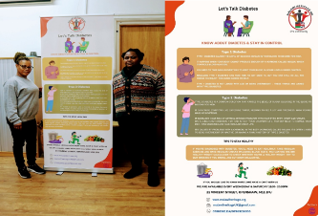  An additional benefit is that the project supported the hub to get more established in the community, as volunteers made themselves available to the community at specific opening times (mainly in the evening). Almost 29-30 people attend our Centre every week.  The Health Creators gained a vast amount of knowledge and shared their knowledge with their friends and families, e.g. Health Creator (Tina) met an acquaintance at the bus stop and explained both diabetes to her– excellent!  Health Creators continue to share information as they valued the project (THCF) and the Project enabled the hub to ‘have a direction/purpose’, supporting the community.
Outcomes | - Health Creators more confident to talk to people  - Health Creators knowledge increase in diabetes  - Resources produced  - Hub recognised in the community  - Increased awareness in local community – Type 1 and Type 2 diabetes

