Title  Aim | Empowering health creators to deliver introduction to mental health training  - Increase health creators confidence to deliver a session.  - Provide an opportunity to share knowledge, power and skills through working together in pairs to deliver the session.  - Develop a good understanding of mental health via the pre-preparation of fact finding on their particular section of the session.
Description  (200 words) | After an initial training session attended by 50 participants, designed to support Health Creators to understand their role and responsibilities, a number of participants chose mental health within the South Asian communities as the theme for this project  The guidance Hub worked with the health creators interested in taking this forward and helped organise a community empowerment training workshop; An Introduction to Mental Health.  The Health Creators wanted to increase their knowledge and experience in not only discussing mental health amongst South Asian communities but also wanted to gain experience in delivering some of the session.  On Saturday, February 17, 2024, the Health Creators Community Empowerment Training Session took place at the Guidance Hub. The primary objective of the training session was to provide participants with a comprehensive understanding of mental health, emphasising its impact, delving into its underlying causes, and equipping attendees with the knowledge and skills necessary for self-care and supporting others.  The programme consisted of the following four strands and each section was delivered by two health creators. A total of 8 health creators were involved in this case study.  - What is mental health and mental illness. BA and MA  - Mental Health and Mental Illness. SS and RU  - Impact of Stigma, Discrimination and Stress. AH and AK  - How can we improve our mental health and support others. HK and IS  The trainer provided each participant with the health creation Framework Evaluation Wheel sheet. The participants were asked to complete the wheel sheet inserting “B” before they started the training session and then come back to the wheel sheet to complete the sheet by inserting “A” after they had done the training.  The training session employed an interactive delivery approach, fostering active participation amongst the attendees. Facilitated and supervised by experienced trainer, Maqsood Ahmad, the session aimed to empower participants with practical insights and strategies for managing mental health, both personally and in a supportive role towards others.  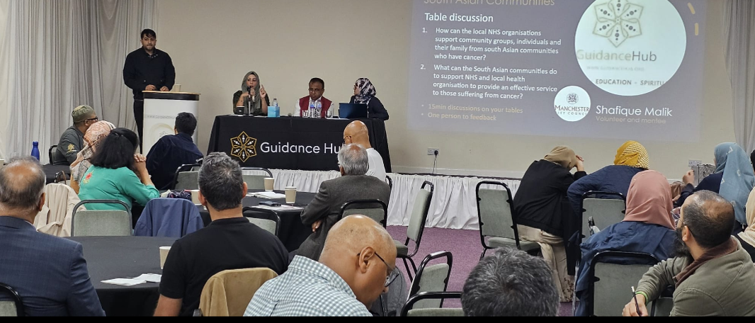  The main benefits included: increased in confidence in public speaking, increased knowledge of individuals on the subject matter of mental health, team working skills by working as a group and in pairs to deliver the training.
Outcomes – | - Individuals felt empowered to contribute and share responsibilities.  - individuals felt more engaged and responsible for their own learning experiences  - Health Creators increased confidence in delivering training  Health creators’ quotes included:  “it was good to work in pairs - give me the chance to get to know AS while we were preparing for our section of the presentation.” AU  “I gained a considerable amount of information on mental health through reading various articles prior to covering my section. Particularly the 5 Ways to health and wellbeing was very good approach for individuals to look after themselves”. HK  “I enjoyed working with the group and with my allocated partner to delivery the section on the impact of stigma and discrimination. I found the peer group feedback on my presentation very helpful.” AH

