Name: | Adeela Rathore and Ruqia Allana
Organisation: | Hopewell Charity Organisation

Title  Aim: | Winter Health – Covid and Flu vaccination project  - To identify and dispel COVID-19 vaccination fears (Eradicating vaccination related misconceptions)  - To increase understanding of the barriers to vaccinations  - Increase Health Creator’s ‘Winter Health’ knowledge.  - Increase Health Creator’s confidence to manage their own health
Description | The project was delivered by Adeela Rathore (project lead) with 8 Health Creators. As part of Winter Health, the group focused on the Flu and Covid-19 vaccinations.4 Sessions were held by the VCSE lead:-  1st Session – Winter health – what is this? This session introduced the project and explored what ‘Winter Health’ means.  2nd Session – Collating community views/opinions on Covid-19 and flu vaccinations. The Health Creators talked to people in their community who had, had one or both vaccinations and from the information, a short questionnaire was produced to identify ‘needs’ to stay well, managing their health and concerns regarding the Covid-19 and Flu vaccinations. It was important for the Health Creators to understand why people from their community get ill in Winter and what steps could be taken to avoid this; including the importance of taking up the Flu and Covid-19 vaccinations. The implications of flu and covid on existing medical conditions including Diabetes, Asthma and other conditions was also explored.  3rd Session - Information finding – During this session the Health Creators found websites informing them on how to access the vaccinations (booking sites and the availability of vaccinations locally). Factual information was also sought on side effects to eradicate misconceptions and misinformation, (promoting the use valid internet sites such as NHS, Gov.uk, GP’s, MLCO, Cheetham and Crumpsall Integrated Health etc) – record info found. Impact of other existing health conditions on the community was investigated within the context of health inequalities.  4th Session – During this session, resources were produced i.e. leaflet and video.  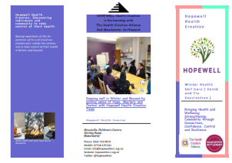  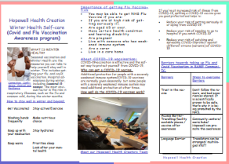  A unique aspect to this project, when compared to other projects was that the project lead delivered the sessions in her own language to the group and translated information.  Hopewell explained that they deliver many sessions under similar principles to Health Creation; but took the opportunity to delve deeper into the theme to expand  their knowledge and practice.
Outcomes – | - Health Creators confidence increased (linked their personal experiences with the 6 features and 3C’s and additional aspect added; Resilience)  - Health Creators feel empowered (increased skills and knowledge)  - Leaflet produced to share with their community  - The main features embedded- listening and responding, strengths-focused, self-organising and reciprocity

