Name: | Elizabeth Shaba-Appoh
Organisation: | Ceebee Gold Foundation

Title:  Aims: | Winter Health - “Get Moving”  - Increase group participants confidence to increase their physical activity/to promote an active lifestyle  - Encouraging participants to experience different activities  - To increase participants knowledge of the benefits of healthy eating and physical activity
Description  (200 words) | 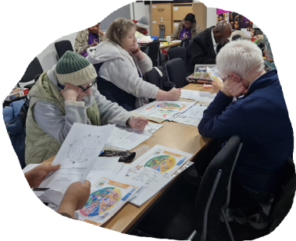  Project co-ordinator hired to support the project delivery to increase physical activity within an educational program. The project focused upon building the self-esteem of a mixed group of individuals aged between 18 to 85 years of age!  Healthy exercise options were introduced to the group members which included walking, gym activity and light aerobic exercise. Motivational health topics were also conducted during shared community meals. Used this platform to discuss vaccinations and group led health discussions.  - The group met weekly and once the group understood the project, they began the interventions. The group was split into smaller groups with a group leader who had responsibility for getting feedback and managing the physical activities. Members were held accountable for their physical activity actions/weekly goals and monitored to ensure participation and transparency. Smaller groups encouraged meaningful engagement and support for each other.  - The physical activity program had to be adapted to be inclusive i.e. elderly people wanted to engage slowly and at a varied pace. Therefore, the program was structured with low impact exercises which would suit all ages.  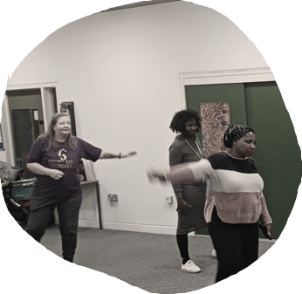  - Community cohesion was evident as members encouraged each other. The ‘Evaluation Wheel’ was used to measure the 3C’s and reported an increase in self-confidence and positive physical and mental health, as well as an increase in physical agility. Members became self-reliant and were happy with the selection of physical activity exercises which suited their ideal age range.
Outcomes | - Improved health (physically and emotionally – measured by Evaluation Wheel).  - Well organised project that the community group enjoyed  - Participants increased physical activity at home also  - The 3C’s and 6 features were all embedded in the project

