HIS3346: The Rising Generation: Youth, Age and Protest in Post-War Britain
Dr Laura Tisdall (Newcastle University)
laura.tisdall@newcastle.ac.uk

Week 7: Children, schooling and the children’s rights movement

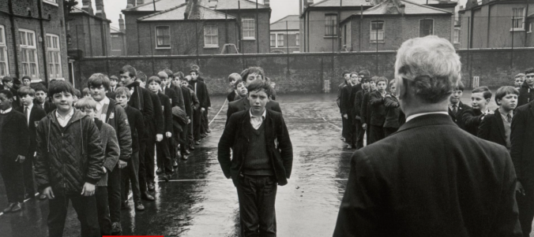

Battersea Secondary School in London, 1967. Credit: Ullstein Bird/Getty, via the Guardian [https://www.theguardian.com/news/2017/may/04/grammar-schools-secondary-modern-11-plus-theresa-may]

Set Reading

- John Holt, Escape From Childhood: The Needs and Rights of Children (1974)
- Mathew Thomson, Lost Freedom: The Landscape of the Child and the British Post-War Settlement (2013)
- Owen Emmerson, ‘No to the cane’, Jacobin, read online at https://jacobinmag.com/2017/10/scotland-corporal-punishment-britain-schools-action-union, [on school strikes in the 1970s]

Recommended Extra Reading

- DES, West Indian Children in our Schools: Interim report of the Committee of Inquiry into the Education of Children from Ethnic Minority Groups (London, 1981) http://www.educationengland.org.uk/documents/rampton/rampton1981.html
- Laura Tisdall, ‘ “The school that I’d like”: children and teenagers write about education in England and Wales, 1945-79’, in Children’s Experiences of Welfare in Modern Britain ed. Siân Pooley and Jonathan Taylor (IHR Conference Series, 2021), open access here https://sas-space.sas.ac.uk/9590/1/9781912702886_WEB.pdf
- Laura King, ‘Future citizens: cultural and political conceptions of children in Britain’, 1930s-1950s, Twentieth Century British History, (2016), uploaded onto Canvas.

Additional Reading

Childhood
Mathew Thomson, Lost Freedom: The Landscape of the Child and the British Post-War Settlement (2013), ebook.
Laura Tisdall, A Progressive Education? How Childhood Changed in Mid-Twentieth-Century English and Welsh Schools (Manchester: MUP, 2019), Introduction, Ch. 7, ebook.
Ben Highmore, ‘Playgrounds and bombsites: postwar Britain’s ruined landscapes’, Cultural Politics, 9, 3 (2013)
Krista Cowman, ‘Play streets: women, children and the problem of urban traffic, 1930 – 1970. Social History, 42 (2017)
Jennifer Crane, Child Protection in England, 1960-2000: experience, expertise and emotions (2018), Introduction, available online here: https://www.palgrave.com/gp/book/9783319947174

Childrearing and childbirth
Pat Thane and Tanya Evans, Sinners? Scroungers? Saints? Unmarried Motherhood in Twentieth Century England (2012), chs 5 and 6
Laura King, ‘Hiding in the pub to cutting the cord?’ Social History of Medicine 30, 2 (2017)
Laura Tisdall, ‘Education, parenting and concepts of childhood,’ Contemporary British History (2017)
Angela Davis, Modern Motherhood (2014).
David Cowan, ‘ “Modern” parenting and the uses of childcare advice in post-war England’, Social History, 43, 3 (2018)

Education and schooling
Peter Mandler, ‘Educating the Nation I: Schools,’ Transactions of the Royal Historical Society, 24 (2014)
Peter Mandler, The Crisis of the Meritocracy: Britain’s Transition to Mass Education since the Second World War (2020)
Carolyn Steedman, ‘“The mother made conscious”: the historical development of a primary school pedagogy’, History Workshop Journal, 20 (1985)
Laura Tisdall, ‘Inside the “blackboard jungle”’, Cultural and Social History, (2015).
Laura Carter, ‘“Experimental” secondary modern education in Britain, 1948–1958’, Cultural and Social History, (2016)
Jessica Gerrard, Radical Childhoods: schooling and the struggle for social change (Manchester: Manchester University Press, 2014) [material on Black supplementary schools], ebook.
M. Stone, The Education of the Black Child in Britain: The Myth of Multiracial Education (1981).

Primary sources

Ian Lister. ed., Deschooling: A Reader (1974).
Secondary Education and Social Change in the United Kingdom since 1945 https://sesc.hist.cam.ac.uk (Peter Mandler, Chris Jeppesen and Laura Carter)
Education in England: the history of our schools (Derek Gilliard) http://www.educationengland.org.uk

Week 8: Adolescence and student protest

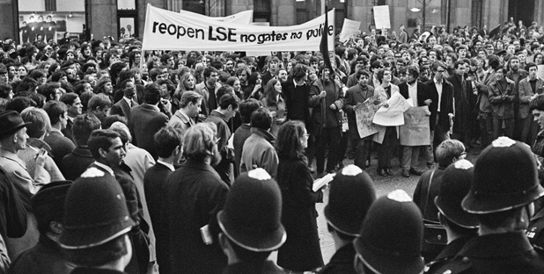

Students occupy the London School of Economics (LSE) in 1969 to protest the appointment of Walter Adams as Director, due to his links to the rightwing regime in what was then Rhodesia.

Set Reading

- Selina Todd and Hilary Young, ‘“Baby-boomers’ to ‘beanstalkers”’: making the modern teenager in post-war Britain’, Cultural and Social History (2012)
- Nick Thomas, 'Challenging Myths of the 1960s: The Case of Student Protest in Britain', Twentieth Century British History, 13 (2002).

Recommended Extra Reading

- A nice introduction to 'Generation X' can be found here: www.bbc.co.uk/programmes/b03wgt9r
- Hera Cook, The Long Sexual Revolution: English Women, Sex and Contraception 1800-1975 (2005)
- Jodi Burkett ed., Students in Twentieth-Century Britain and Ireland, Introduction, chapters by O’Neill, Smith and Burkett, open access e-book https://link.springer.com/book/10.1007%2F978-3-319-58241-2

Additional Reading

Adolescence
Carol Dyhouse, Girl Trouble: Panic and Progress in the History of Young Women (2013), ebook.
John Davis, Youth and the Condition of Britain: images of adolescent conflict (London, 1990)
Liz Heron ed. Truth, Dare or Promise: Girls Growing Up in the Fifties (1985)
Gillian Mitchell, ‘Reassessing “the generation gap”: Bill Haley’s 1957 tour of Britain, inter-generational relations and attitudes to rock ‘n’ roll in the late 1950s’, Twentieth Century British History (2013)
Jane Elliott, ‘ “Talkin’ ‘Bout My Generation”: Perceptions of Generational Belonging Among the 1958 Cohort’, Sociological Research Online, (2013), read online here: http://www.socresonline.org.uk/18/4/13.html
Rosalind Watkiss Singleton, ‘ “(Today I met) the boy I’m gonna marry”: romantic expectations of teenage girls in the 1960s West Midlands’ in Youth culture and social change: making a difference by making a noise ed. Lucy Robinson et al. (2017), ebook.
Laura Tisdall, ‘“What a difference it was to be a woman and not a teenager”: adolescent girls’ conceptions of adulthood in 1960s and 1970s Britain’, Gender and History (2021)

Heterosexuality, sex and contraception
Kate Fisher, Birth control, sex and marriage in Britain, 1918-1960 (2006), ebook.
L. A. Hall, Sex, Gender and Social Change in Britain since 1880 (2000), ebook.
Roger Davidson, Illicit and Unnatural Practices: the law, sex and society in Scotland since 1900 (Edinburgh: Edinburgh University Press, 2018), ebook.
Hera Cook, ‘The English sexual revolution: technology and social change’, History Workshop Journal 59:1 (2005), pp. 109-28
Lesley A. Hall, 'Eyes tightly shut, lying rigidly still, and thinking of England? British women and sex from Marie Stopes to Hite 2000,’ in Nelson and Martin (eds), Sexual pedagogies : sexual education in Britain, Australia, and America, 1879-2000 (2004), ebook.
M. Collins, Modern Love: An Intimate History of Men and Women in Twentieth Century Britain (2003)
Angela McRobbie, ‘Top Girls: Young Women and the Post-Feminist Sexual Contract,’ Journal of Cultural Studies 41, no. 4– 5 (2007)

Students and racial/internationalist protest
Jodi Burkett, ‘The National Union of Students and transnational solidarity, 1958-1968’, European Review of History (2014)
Sylvia Ellis, ''A demonstration of British good sense?' British student protest during the Vietnam war'', in Gerard J. DeGroot, ed., Student protest. The sixties and after (1998)
Caroline Hoefferle, British student activism in the long 1960s (2013), ebook.
Ronald Hyam and Peter Henshaw, The Lion and the Springbok: Britain and South Africa since the Boer War (2003), ch. 13, ‘Springbok reviled: some British reactions to Apartheid, 1948-1994’, ebook.

