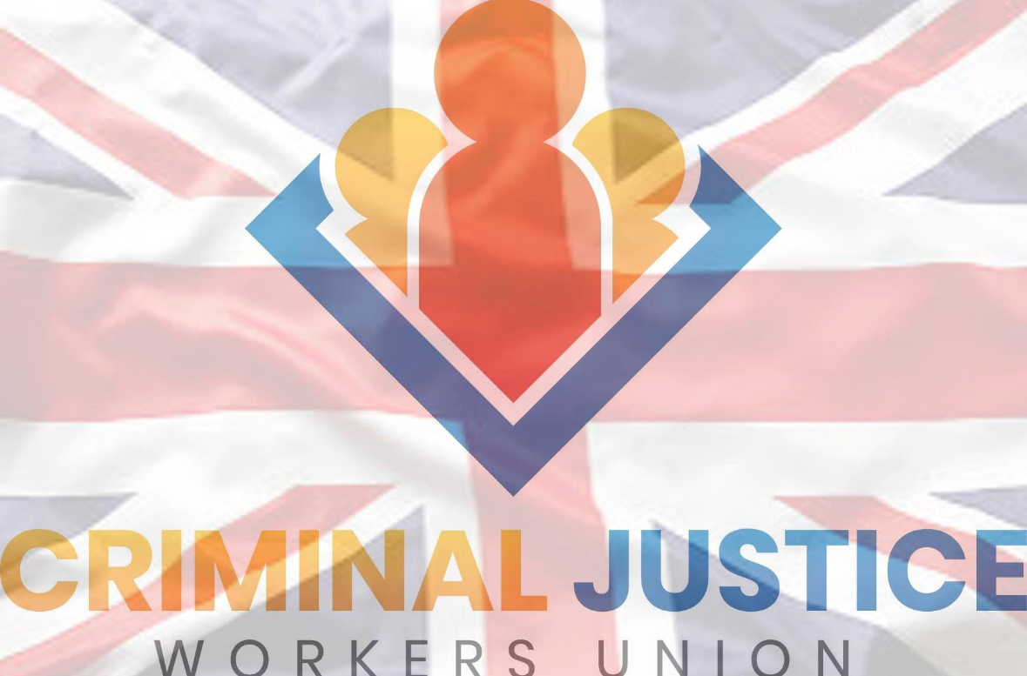

**Criminal Justice Workers’ Union (CJWU)**

**Minutes of Meeting**

Date: Wednesday 10 September 2025

Time: 19:00

Venue: Zoom

**1. Attendance**

Present: Mike Rolfe, Aaron Stowe (Chair), Barry Bishop, Ray Castlehow (to join if possible)

Apologies: Ray Castlehow (working nights)

**2. Agenda**

1. Membership numbers and recruitment  
2. New pin badges  
3. £500 raffle draw  
4. Five-year membership badges  
5. Monthly raffle  
6. Current finances  
7. Updates and actions

**3. Standing Items**

- Confirmation of dates for future meetings  
- Finance reports – via WhiteFuse  
- Meeting minutes to be published within 24 hours  
- Updates and action tracking

**4. Reports & Updates**

- President’s Report: To be circulated by Aaron.  
- Administration: Laura continuing with admin and preparation work.  
- New Items (Mike): Raised for future discussion.  
- Raffle Concerns (Ray Castlehow): Highlighted risks but supported as a good idea with stronger planning.  
- Membership: Agreed need to focus on growth and retention.

**5. Raffles & Draws**

- A raffle will be run on the 15th of October and monthly thereafter with a first prize of £200, second prize £100 and third prize of £50, there will be no additional costs to members and all members, except the Executive committee, and employees will be entered into the draw. The draw will be held by the president on a live feed. For data protection purposes, membership numbers to be used rather than names.  
- Google Auto Raffle: confirmed no additional costs for members.  
- Draws to be overseen by President.  
- Monthly draws to be livestreamed on the 15th of each month.  
- £500 5 year anniversary raffle draw scheduled for 15 September 2025.  
- Full monthly raffle launch confirmed for 15 October 2025.

**6. Finance**

- Database to be updated monthly.  
- Finance report to be provided as summary figures/screenshots.  
- WhiteFuse/GoCardless to remain in place (some memberships still pending).  
- Laura to continue oversight of administration and run reports going forward.

**7. Legal & Casework**

- Concern raised about high legal costs.  
- Example: £4,000 spent to win £1,000.  
- Agreement reached:  
 • Cases should only be pursued where value outweighs cost.  
 • Legal team to make recommendations on which cases proceed.  
 • Approx. 50% of income to be allocated to legal fund.  
 • “Pay as you go” approach to reduce risk of unpredictable bills.  
 • More scrutiny on case selection to ensure sustainability.

**8. Membership & Communications**

- Drive to increase membership numbers.  
- New pin badges to be ordered.  
- Membership database to be updated; welcome packs to be issued backdated to January.  
- New biography for website required.  
- New leaflet design to be developed.

**9. Actions Agreed**

1. Aaron to finalise and circulate President’s update.  
2. Laura to continue with admin and membership database updates.  
3. Finance report (via WhiteFuse/GoCardless) to be provided monthly.  
4. Raffle to launch October 15th; £500 raffle draw confirmed for September 15th.  
5. Membership growth campaign – badges, packs, leaflet design.  
6. Legal services to be tightened.  
7. New website biography to be drafted.  
8. Future meeting dates to be agreed and diarised.

**10. Close of Meeting**

The meeting opened at 19:00 and concluded at 20.45 hours.