#1601

anneHearnden
Heart for Knitted Knockers

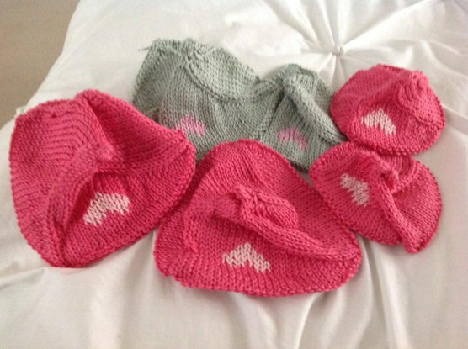

Materials Blunt needle
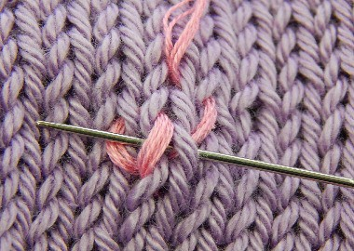6 stranded embroidery thread approximately 32-35 inches (80-90cm) will complete one heart

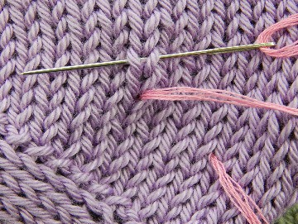
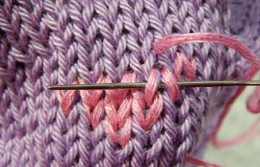Use a waste knot, or just leave your thread resting on top of your work away from the starting point.

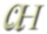Use all 6 strands of embroidery thread. Separate them one at a
time, the threads will then lay flat instead of twisted and will cover the stitch better. Use a blunt needle to avoid splitting any threads or yarn

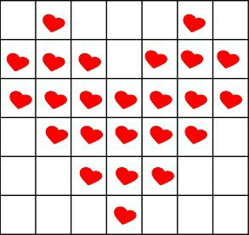

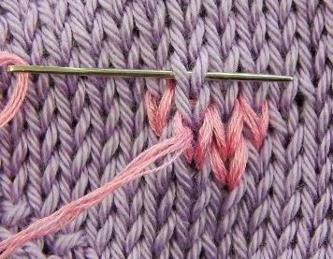

Weave your ends in when you have finished, leave a very short tail inside to avoid the end popping through to the right side.

©Anne Hearnden 2016 email: annehknits@gmail.com
160108

