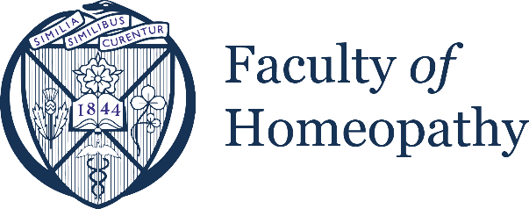

FACULTY QUALITY ASSURANCE SCHEME

A. Aims and objectives of Quality Assurance (QA)
The ‘course provider’ Quality Assurance (QA) scheme by the Faculty of Homeopathy is an audit process of an organisation or institution (at any registered location worldwide), providing basic and/or continuing education and training in homeopathic medicine. The qualification attained does not necessarily need to lead to registered licensed practice in homeopathy within their sector.
The QA scheme is not for the purposes of accreditation of courses for professional/practitioner licensing or registration. It does not confer a licence to practice for graduates of the course programme and does not make your graduates eligible to apply to the Faculty of Homeopathy for membership.
By contrast, the QA scheme seeks to measure the course provider and its programmes against their own internal ethos, learning outcomes, curriculum and training level. It is an audit rather than an appraisal or accreditation. It is a validation that you are performing well, and delivering what you aim to deliver. It thereby imparts reassurance and confidence in those who may rely on your programmes, such as prospective students, licensing bodies and so on.

B. Benefits of Quality Assurance
The QA award may benefit the Course provider when making other applications for accreditation to other national registering/regulatory organisations.
The QA certificate is advantageous when marketing and promoting your courses.
The Faculty of Homeopathy lists QA certified courses within their website, newsletters and trade magazine – further promoting your services.
The process of achieving and maintaining your QA certificate could greatly benefit your centre and course programme development. Our Academic Board is able to provide expert advice to support your short and longer term plans.
An award of QA entitles you to use the statement ‘Faculty of Homeopathy Quality Assured Centre’, alongside the Faculty QA logo, on your website and promotional material.

C. Scope of Quality Assurance
The QA certificate applies to the both the Course Provider and the specific course programmes that are delivered. The cost of QA certification depends on the number of course programmes within the application. The basic fee applies to 2 course programmes, additional programmes require added fees to fulfil the appraisal workload required.

C. Quality Assurance approval protocol

1. Initial application
A course provider seeking quality assurance must make an initial application to check their suitability for full application. The initial application form provides preliminary information to enable us to check your eligibility and suitability for quality assurance.
In all cases notification of requests must be made in writing to the Faculty of Homeopathy, by email, to our administrator at the following address: lpeacock@facultyofhomeopathy.org

2. Submission of materials
The full application process requires completion of a more detailed form to provide a comprehensive overview of your course programmes. Supplementary evidence is provided through a range of documents, course materials and access to your programme. See appendix for the list of evidence required.

3. QA visit
In the majority of applications, one visit is required to complete the audit process. This is usually feasible as a remote access visit, but it can be completed as several online sessions. This may include witnessing a live classroom teaching (whether by attendance or online), and interviewing key staff members.

4. Academic Board approval
The Faculty of Homeopathy Academic Board will need to ratify all QA approval outcomes. Full QA status may be offered, or pending/conditional on receiving further evidence and fulfilling key recommendations.

5. QA approval periods
When granted, QA certification will be for 3 years, unless an alternative period of QA is confirmed in writing by the Faculty.
It is the responsibility of the course provider to ensure that up-to-date details are provided.
The Faculty reserves the right to withdraw QA approval in extreme circumstances.
The process of renewal of QA status involves an abbreviated re-application, with a focus on changes on the course programme or institution. A repeat visit and review of course documentation also takes place.

C. Cost of Quality Assurance
There is no fee for the initial application when enquiring as to your eligibility for the full application to the QA scheme.
The fee payable for the full application is £750 to cover the desktop review of the institution and course programme and attendance/remote visit.
If approved for a QA certificate, the fee payable for a 3 year term is £2250.
The fee for renewal of the QA certificate is £2250, for another 3 year term.

