DR. ATUL JAGGI

H3 - Health & Happiness by Homeopathy

Centre of Classical Homeopathy, Nashik, Maharashtra, India

E mail – atuljaggi@yahoo.com

Website: www.classicalhomeopathy.in

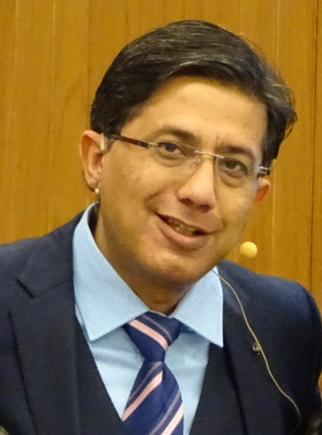

Dr. Atul Jaggi is the Director of H3 – Health & Happiness by Homeopathy, Centre of Classical Homeopathy in Nashik, Maharashtra, India.
He began his homeopathic studies in 1991 at one of India’s premier college: Nehru Homeopathic Medical College and Hospital, New Delhi.
In 1996 he joined the first Four Year Course at the International Academy of Classical Homeopathy (IACH), Greece and graduated in the top three of his class amongst 170 International doctors.
He has attended the summer courses at IACH in Greece for the last 24 years.
He now assists Professor George Vithoulkas and also teaches at IACH during the summer courses in Alonissos.
Since 2013, he has been moderating the IACH E-learning Course and now acts as Senior Co-ordinator managing the multiple groups in the various cities of India.
Currently, Dr. Jaggi lectures at International seminars in India, Greece, Russia, Spain, Egypt, Romania, Malaysia and Ukraine where he has been invited as a speaker. Also he has given webinars in other countries like USA, Australia, Chuvash Republic etc.

His main mission is to bring students in contact with the precious and life changing teachings of Professor George Vithoulkas and spread real Hahnemannian Classical Homeopathy.

