DR. ATUL JAGGI

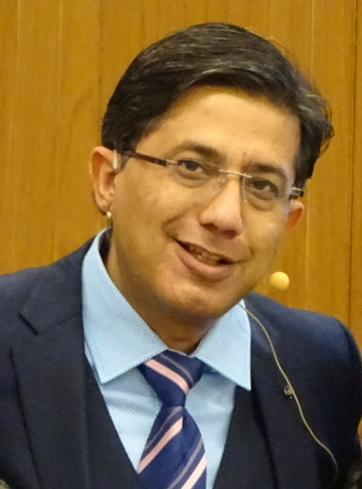

Dr. Atul Jaggi has been working in the field of homeopathy for the past 30 years. As the Director of the H3 – Health & Happiness by Homeopathy, Centre of Classical Homeopathy, he is dedicated to advancing the practice of Classical Homeopathy.

Dr. Jaggi began his homeopathic studies at Nehru Homeopathic Medical College in New Delhi and later graduated among the top three at the International Academy of Classical Homeopathy (IACH) in Greece.

Over the years, he has assisted Professor George Vithoulkas and taught at IACH's summer courses.

He also moderates the IACH E-learning Course and coordinates multiple groups across India.

Dr. Jaggi is an esteemed international speaker, delivering lectures and webinars worldwide, with a primary mission to connect students with the transformative teachings of Professor George Vithoulkas.