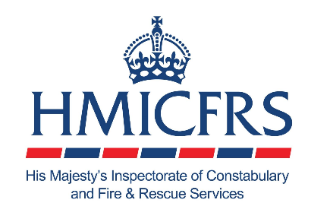

Subject: Have your say on the firearms licensing system in England and Wales: complete our survey by 5 December
Dear Registered Firearms Dealer,
His Majesty’s Inspectorate of Constabulary and Fire & Rescue Services (HMICFRS) is inviting you to take part in a survey as part of our inspection of the firearms licensing system in England and Wales.
You can access our survey using this link. Please complete the survey by 5pm on Friday 5 December 2025. It should take you approximately 15 minutes.
About us and our inspection
HMICFRS independently assesses the effectiveness and efficiency of police forces and fire and rescue services to make communities safer.
In our inspection, we will consider the effectiveness and efficiency of the firearms licensing system across police forces in England and Wales.
Alongside other evidence gathering methods, we are distributing a survey to registered firearms dealers to better understand your experiences with the firearms licensing system.
Completing this survey is an opportunity to share your experiences and feedback. Your responses will help us to identify where the system is working well and where improvements are needed.
How we will use your data
We will anonymise the survey responses and use the analysis in our inspection report to inform recommendations for improving the firearms licensing system. Our inspection findings won’t identify you or your business.
Any information you give will be kept confidential and managed securely. See our privacy notice for more information.
Voluntary participation
It isn’t mandatory to complete this survey. But it is a valuable opportunity to share your experiences with the firearms licensing system and allows us to reflect your views in our inspection evidence.
You can withdraw your responses at any time before we publish our inspection findings by completing this survey.
If you have any queries about this survey, please contact HMICFRSsensitiveresearch@hmicfrs.gov.uk
Thank you in advance for completing the survey.

Kind regards,

