

**Committee Member Profiles 2024/25**

**Proposed**

Lee van CRUGTEN, Membership Secretary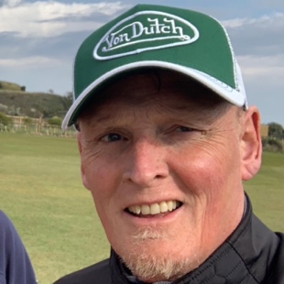

Served 34 years in the military retiring in 2013 and now enjoying a second career contently running a private cemetery in Plymouth UK. With no musical background what so ever , I am currently learning diatonic harmonica as a life time student in Tomlin Leckie’s harmonica school. I have to admit to playing golf more than I play harmonica these days.

**Existing**

**Gene Myers, Editor and IT Support/Acting Chair**

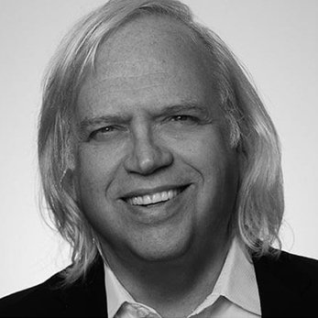My father played harmonica, but it was after I saw James Cotton perform in 1977 that I bought my first diatonic harmonica and started playing. I’ve had a diverse professional life in the visual arts and technology that has demanded my attention for most of my adult life. In 2013, I picked up the harmonica again, but only in 2019, when I discovered Harpin’ by The Sea, hosted in my neighbourhood, did I become hooked and soon after joined Harmonica UK. I mainly play blues on diatonic harmonica but have recently developed an interest in chromatic, tremolo, and bass harmonicas, as well as traditional Irish music. I’m the Founder, Board Member, and Chief Technical Officer of a listed public technology company.

**

Great, another accountant, said no one ever! Like most people I started playing guitar at school with a friend, some years later I spent a year at the Guitar Institute in Los Angeles, learning everything I could. I played in a few bands, weddings, wakes, masonics and synagogues. I only play now and again, leap years. Harmonica was never something I wanted to learn until a friend introduced me to Sonny Terry in 2015. I have had a number of close calls with the harmonica since then and finally decided to commit to learning in 2021.

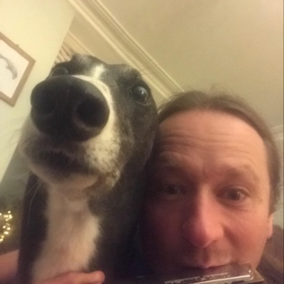

**Simon Joy, Secretary & Safeguarding / Good Practice**

As the only tremolo player on the committee, Simon is carrying the torch for all the members who play tremolo and double reed instruments. He is using his background of working in health and social care to oversee HarmonicaUK’s commitment to safeguarding and managing risk. He looks forward to playing some tunes together.