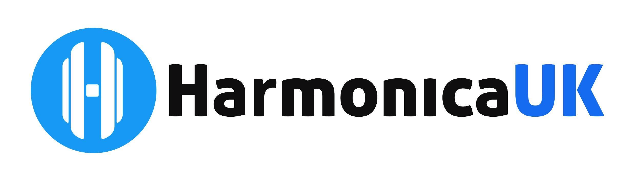

**Communications Report for AGM**

**25th October 2024**

The Communications team has continued to deliver a variety of information to our members and non-members alike. Members receive a monthly newsletter which directs them to any relevant information or interesting stories on the website. This is also our main platform to deliver news in a timely fashion.

We supply links to all relevant news items in the newsletter and to upcoming events, such as Open mic sessions, Saturday Workshop sessions, and the Festival.

Newsdesk continues to provide interesting harmonica stories, facts and tutorials and is available to members and nonmembers alike.

Finally, our social media platforms which are also a source of getting our information out there, plus providing a forum for harmonica players.

A rigorous set of protocols ensures that all material going out is thoroughly proofread and checked before issue.

Suzy Colclough - Communications and Accessibility Manager

2 October 2024