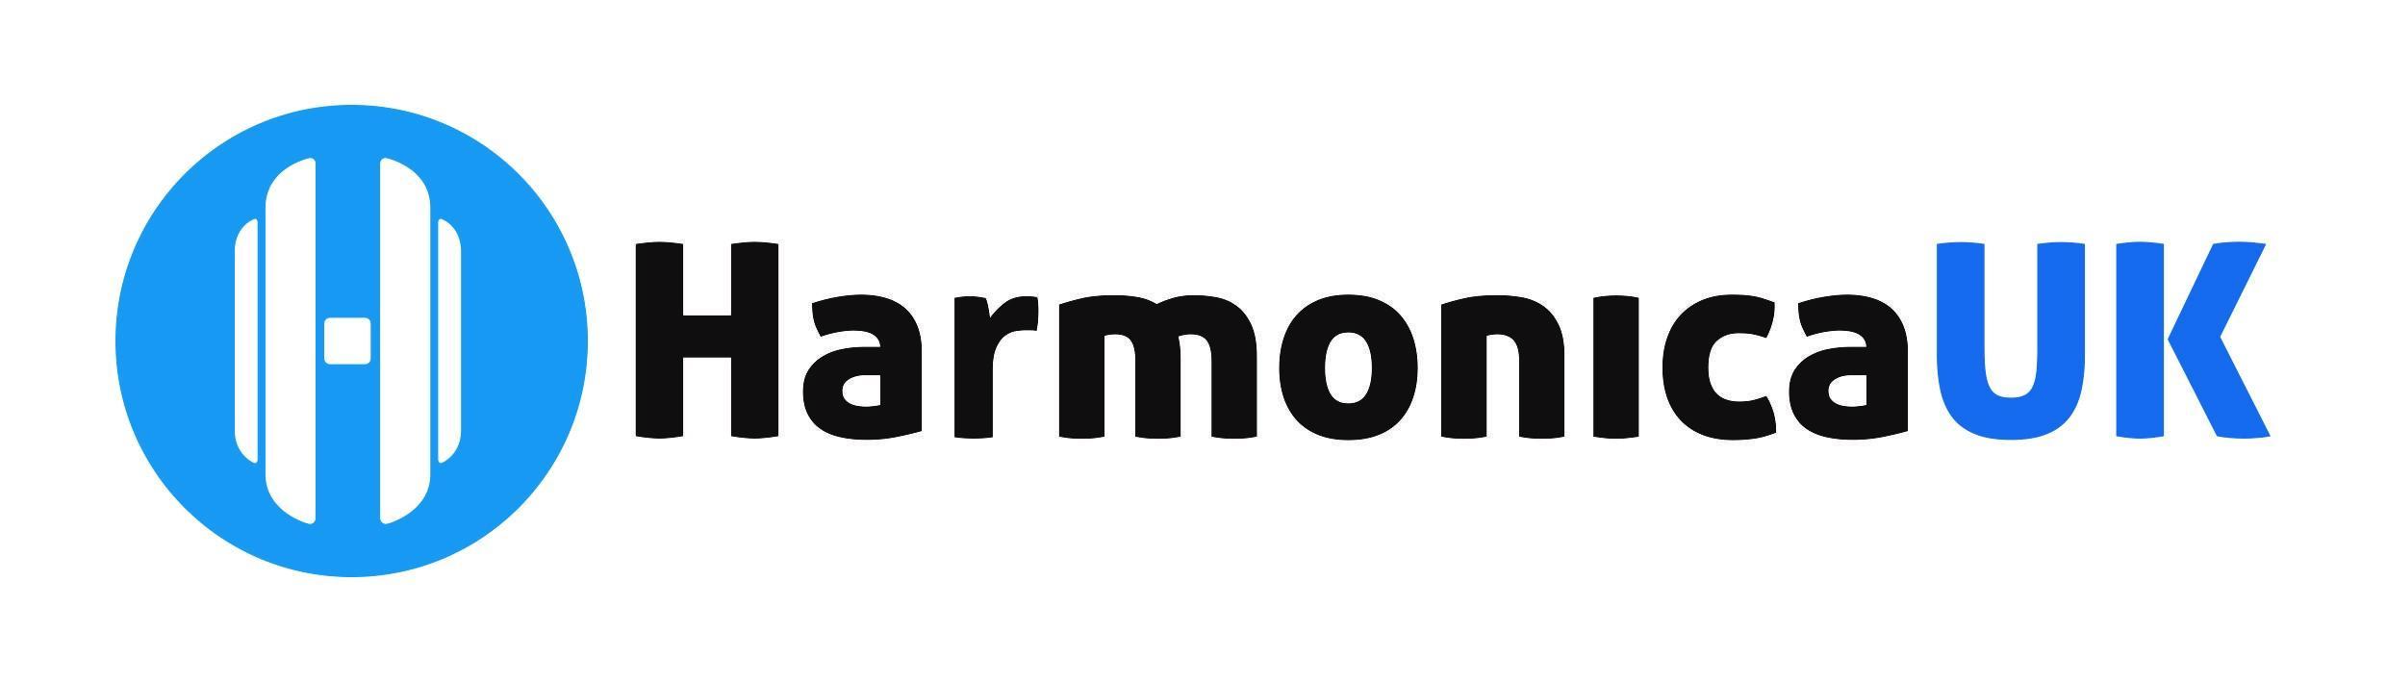

**Membership Report for AGM**

**25th October 2024**

Having received a handover from Barbara Tate, in March 2023, we carried out some housekeeping on the HarmonicaUK website. Where some manually renewed accounts (PayPal and Standing Order) had been missed or added late, the website had automatically expired the subscriptions, and new ones had to be created. This created an anomaly in the new subscription data for that month.

There were 13 new members in March 2023, 10 of them via the trial memberships for Harmonica Mastery students, a further 15 people joined the mailing list that month but did not join as members.

Lee van Crugten - Membership Secretary

2 October 2024