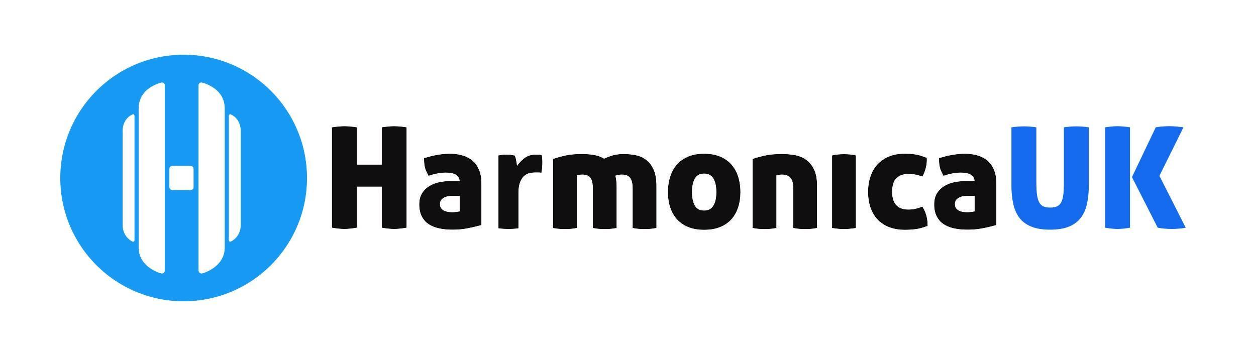

**Chair and Events Manager Report for AGM**

**25th October 2024**

**Chairs Report**

It was a busy year, mainly concentrating on maintaining the services which we provide. We had a reduction in the number of trustees this year due to personal and work reasons. It has been difficult trying to enlist more volunteers to come forward and help with the charity.

I did not have the chance to start any new initiatives which I had planned, such as creating a joint virtual festival with SPAH and looking into sponsoring music teachers to teach harmonica to school classes.

We have had to increase the annual membership fee by £5 across the board to offset the rising costs of printing, web hosting, Zoom, and other operating expenditures.

We have continued to provide the Saturday session workshops, which are only accessible to our members. The Saturday sessions create value for our members and encourage non-members to join so they can access the sessions live and recordings on the website. The open mic sessions posted by Suzy and I remain a firm favourite with members and non-members.

As chair, I also oversee all the teams and groups and reply to all the website-generated messages.

Unfortunately, we have been treading water this year as far as services and opportunities for our members are concerned. We need more volunteers and people helping with HarmonicaUK

to maintain these services going forward.

**Events Manager Report**

Our annual October festival sold out this year in record time. To promote our event, combined advertising was initiated in close liaison with the communications team.

Artists have been approached and commissioned for the festival. Trade exhibitors have been arranged and will exhibit at the festival. Negotiations and liaising with the hotel are ongoing, and Suzy has also been the first point of contact for many of our attendees who require extra help regarding rooms and other matters.

We have also re-introduced the welcome packs, which contain a wristband and a program of the weekend’s events addressed to each attendee. The new wristband system lets staff and crew easily verify what everyone has paid for.

I have liaised with our production manager, Pete Hewitt, who, along with Suzy, has held a production and accessibility meeting for the artists to ensure that all materials supplied by the artists at the festival are accessible to all. I also liaised with auctioneer John Cook and Pippa Phillips who manages our advertising and the trade exhibitors and have secured some excellent prizes for the auction.

We have also commissioned several HarmonicaUK branded harmonicas to sell at the festival this year.

Accessibility and diversity are always major factors when planning festivals, and I hope that is reflected in the program we are offering this year. Preparations have already begun and some artists booked for the 2025 festival.

Dave Colclough - Chair, Events Manager

02 October 2024