CHWs report
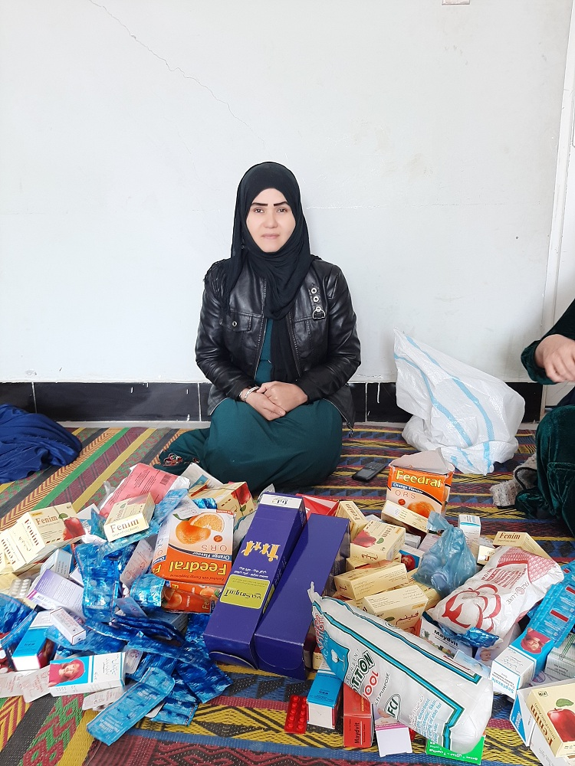
Since August we have been able to start distributing Community Health Workers quarterly packages again. We previously shared these during the local war. Since the summer, considering that the domestic political situation has been very tumultuous, the only service provided by our CHWs was medication distribution.
Up until recently, the health centers have not enough medication to distribute in these difficult times. We have prioritized providing medicine for pneumonia, fever and multi vitamins to support malnourished children.
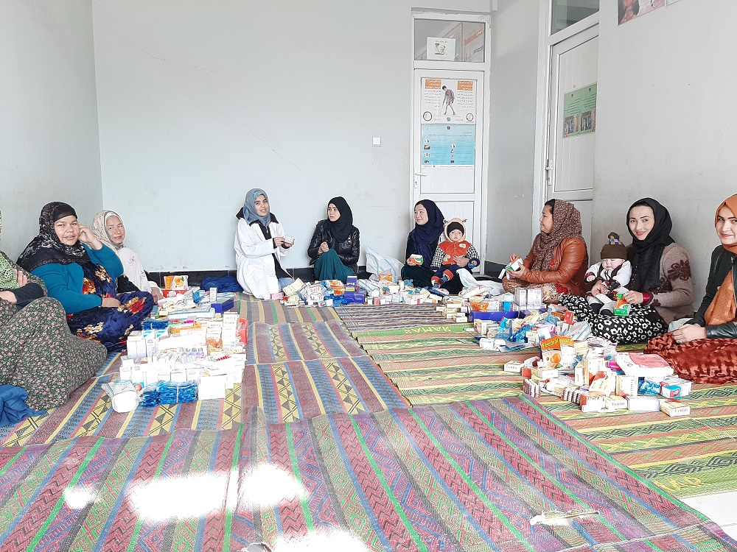
The CHWs are very grateful that our project continues to run despite everything. Their personal accounts of life saving cases shows their resilience even during unimaginable hardships, and we commend them for this. Some of our community health workers feel the strain of this period worse than others, and are experiencing the expectable negative effects on mental health living through regime takeover can impact. Those who need to step away from their work as CHWs for the sake of their mental health are instructed to do so, and we hope to continue providing support for these women however possible.
