Baby blanket report
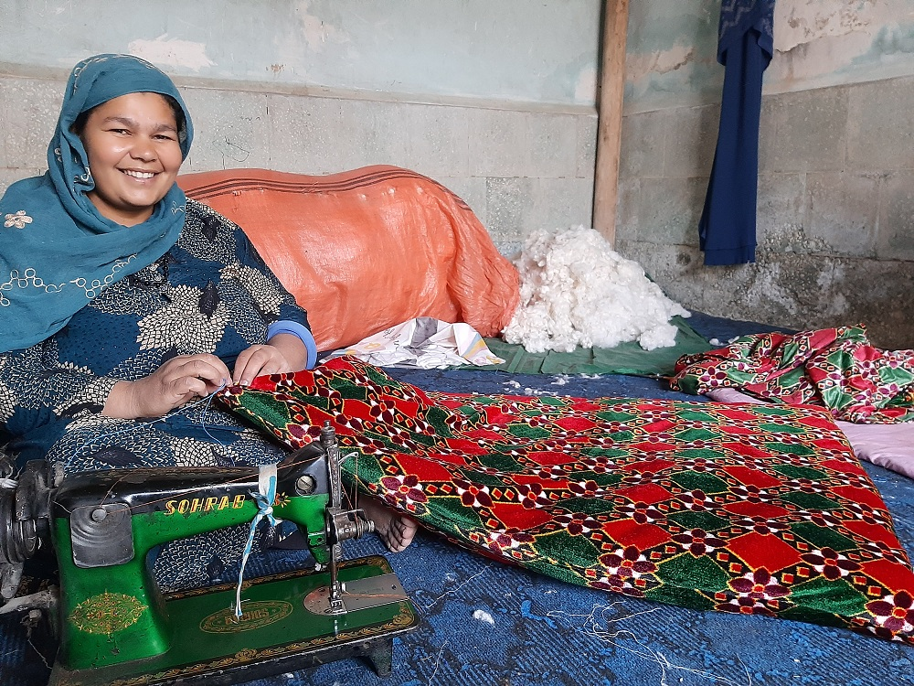
One of the other most useful projects of ours is distributing baby blankets for new born babies. Due to the socio-political circumstances and issues transferring funds, we could not distribute any of these blankets from August until now. Fortunately, we have started distributing blankets to the children our services are aware of who did not receive one in recent months. This is particularly important considering the season change – keeping babies warm in winter, particularly as they return home from health centers as newborns, it is very important.

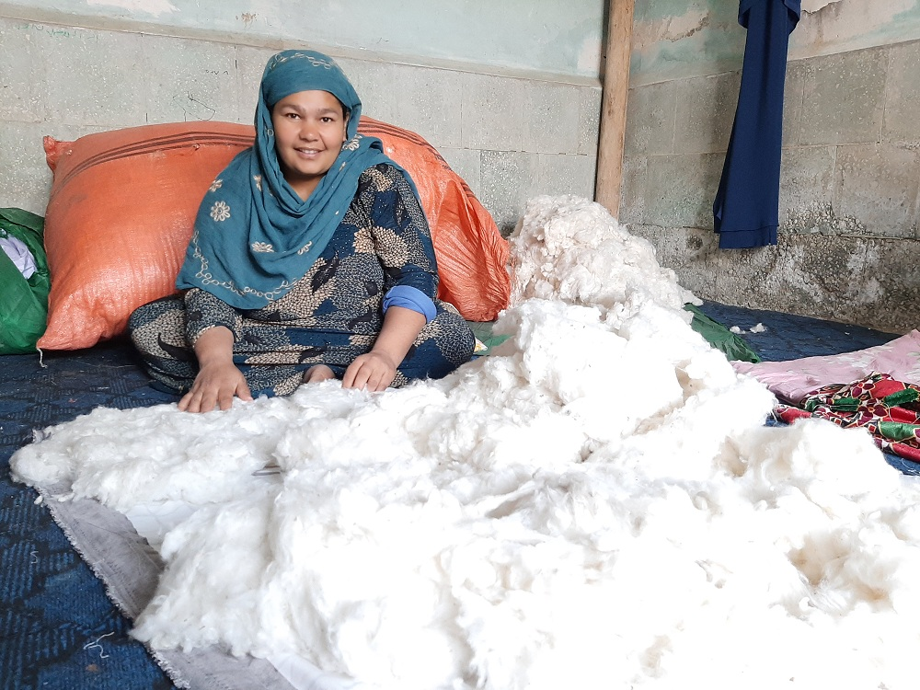
More details will be shared after distributing all remaining baby blankets during ANC visits village by village.

