For over 35 years, HealthProm has been working in Eastern Europe, Central Asia and Afghanistan to support vulnerable children, women and families disadvantaged by poor health, disability or social exclusion. We want to ensure that some of the most vulnerable people are not forgotten in this time of crisis.
OUR OBJECTIVE IN UKRAINE
Children with disabilities and their families are among the most severely affected by the war in Ukraine. Many are spending much of their time in cellars and metro stations, unable to get hold of the most basic necessities for their children.
From 2015 HealthProm has supported a network of over 50 parent-led NGOs, across Ukraine, to campaign for Early Intervention services for children with disabilities and their families. With a lifelong commitment to all vulnerable children, they have been instrumental in developing a new, inclusive, approach to child disability. From Lviv in the west, to the government-controlled regions of Donetsk and Luhansk, they remain united in their determination to protect all vulnerable children in Ukraine. We are now in contact with some 2,500 parents and supporters of children with disabilities, committed to the development of a better world for their children, and now, to their survival.
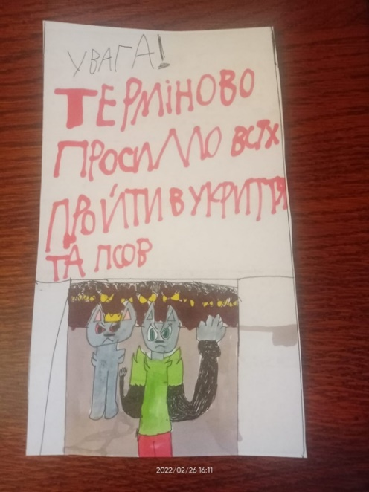
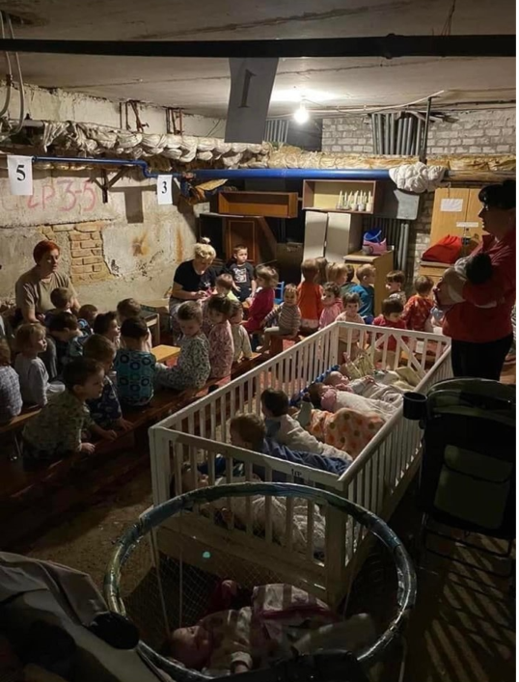

HealthProm is discussing with our parent lead NGOs how best to get them what they need. If it is not possible, or too dangerous, for our network to distribute funds and necessities, we will transfer the funds to organisations that can do this.
Please support our appeal here: https://www.justgiving.com/campaign/emergencyukraineappeal

OUR OBJECTIVE IN THE UK
Our existing Open Doors project, launched in 2019, works with Eastern European and Central Asian Migrant women in the UK facing issues as a result of their migrant status.
The aim of our OpenDoors project is to provide support for vulnerable migrant women from Eastern-Europe and Central Asia living in the UK. HealthProm already has a broad range of expertise in this part of the world - the purpose of this project is to assist migrants from this region living in the UK who struggle with joblessness, social isolation, worsening mental health, low level of English, legal issues; particularly, visa or domestic abuse and lack of digital skills.
We organise the following online activities for our beneficiaries to help counter some of the difficulties they are facing:
Mental health support groups: to help migrant women struggling with various issues as they adjust to life in the UK.
Job Club: Weekly meetings for migrant women seeking guidance on accessing employment in the UK.
Online English classes: speaking clubs, grammar lessons, and support for beginners.
Digital literacy classes: these equip migrant women in the UK with the basic computer skills essential to everyday life.
Due to the ongoing situation in Ukraine, we plan to provide a greater number of activities, particularly mental health support groups, to assist those facing trauma, anxiety and hardship as a result of the ongoing conflict.
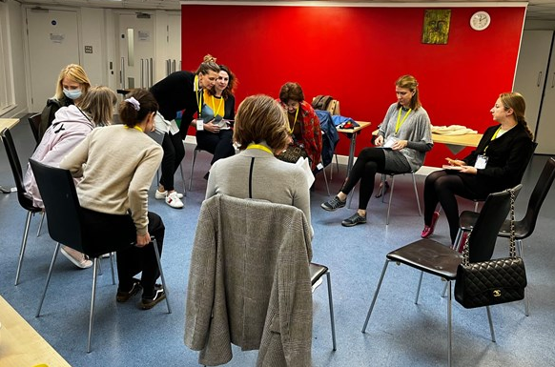

Please support our UK-based work here: https://www.justgiving.com/campaign/opendoorsproject
See more details on our dedicated Open Doors project Facebook page: https://www.facebook.com/OpenDoorsProjectUK

WHAT YOU CAN DO TO HELP
Donate:
Donate to both of our fundraising pages on Just Giving here:
https://www.justgiving.com/campaign/opendoorsproject
https://www.justgiving.com/campaign/emergencyukraineappeal

Set up a monthly donation to our charity via our website here:
https://www.healthprom.org/donation_subscriptions/new

We likewise accept in kind donations or donations of equipment that may be helpful to us as a charity; particularly, we are in need of new computer equipment to help in the every day running of our operations, please email us if you would like to contribute in any way to this: general@healthprom.org

Share:
Please share the details of our organisation and our current projects to your networks and on your social media pages. As well as the above donation links, you can share our website and Facebook page links:
https://www.healthprom.org/
https://www.facebook.com/HealthProm

Get involved:
We would like to link with organisations similarly working on the effort to help people affected by the Ukraine crisis. A united effort is a stronger one, and we believe that much can be learned from the unified nature of past crisis appeals that link NGOs working in the same region. If you are interested in helping set up an NGO forum on the Ukraine crisis with HealthProm, please get in touch by email: general@healthprom.org
Likewise, if you would like to volunteer for our organisation, on any of our existing projects or with our administrative team, please get in touch here: general@healthprom.org

Registered charity number: 1100459
Website: https://www.healthprom.org/
Contact email: general@healthprom.org

