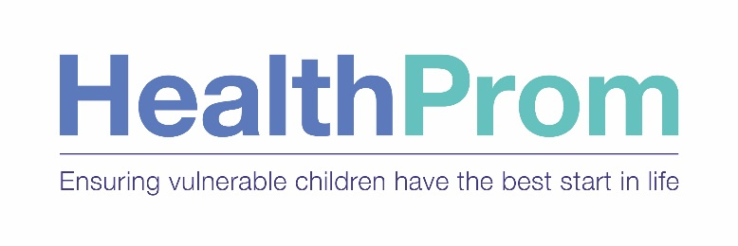

Ethics Policy and Code of Conduct

Ethics Policy and Code of Conduct

1. Introduction

The purpose of this policy is to support a culture of openness, trust, and integrity in all that HealthProm does.
The policy applies to all trustees, employees, consultants, volunteers and partners working on HealthProm projects.

2. Definitions

Ethics –defined as ‘moral principles that govern a person’s behaviour or the conducting of an activity’- and
Ethical standards –defined as ‘Principles that when followed, promote values such as trust, good
behaviour, fairness, and/or kindness’.

3. The Policy

It is the policy of HealthProm to comply with all governmental laws, rules, and regulations applicable to its operations worldwide and to conduct those operations to the highest ethical standards.

We are also committed to the fair treatment of our employees and volunteers; the responsible use of HealthProm’s property and information; to provide accurate, complete and objective information; to respect the confidentiality of financial and other sensitive information held; to act in good faith and exercise due care in all we do and proactively to promote ethical behaviour.

HealthProm has a zero tolerance attitude to fraud and bribery. HealthProm has a zero tolerance of bullying, harassment and exploitation.

HealthProm has a clear set of values which apply to all its operations and should be reflected in everything we do.

4. Code of Conduct

This policy and Code of Conduct requires that trustees, employees, consultants, volunteers, and partners will:
- Act in such a manner as to uphold and enhance the reputation of HealthProm
- Treat with respect and consideration all persons, and not do anything that causes disadvantage because their characteristics of colour, race, religion or belief, gender, pregnancy and maternity, sexual orientation, gender reassignment, marital or family status, disability, age or national origin.
- Make special arrangements, where reasonably possible, so that people are not excluded because of one or more of the above characteristics, for example, ensure disabled access to training.
- Engage in carrying out HealthProm’s mission in a professional manner and in particular
comply with any relevant professional ethics code or standards.
- Conduct operational duties with positive leadership exemplified by open communication, creativity, dedication, and compassion.
- Demonstrate the highest standards of personal integrity, truthfulness and honesty in all activities, in order to inspire confidence and trust in HealthProm.
- Avoid any interest or activity that is in conflict with the conduct of their official duties.
- Respect and protect, and if appropriate keep confidential, privileged information to which they have access in the course of their official duties.
.
.5. HealthProm’s Property and Information Held

We are committed to the responsible use of HealthProm’s assets. Trustees, employees, consultants, volunteers and partners working on HealthProm projects are expected to protect HealthProm’s property at all times; including cash, equipment, records (both electronic and paper), including employee, operational, financial and donor information.
.
All personal information must be handled with great care and treated as confidential. In the UK data must be handled in accordance with HealthProm’s Data Protection Policy.

We provide accurate, complete and objective information, whilst respecting the confidentiality of financial, confidential and other sensitive information.

5. Fraud and Bribery

HealthProm’s Board of Trustees has adopted a “zero tolerance” attitude towards fraud and bribery.
All employees have a duty to report fraud or suspected fraud and bribery as detailed in the Anti-fraud and Bribery Policy. The reporting procedures defined in the Anti-fraud and Bribery Policy should be followed in the event of a fraud or instance of bribery being discovered.
.
6. Our Values
The key principles guiding the charity’s activities are capacity-building for sustainability, evidence-based practice and partnership working, pursued through:
- Commitment to local engagement and partnership;
- Respect for human rights;
- Empowering individuals and communities;
- Commitment to learning, innovation and exchange, and
- Promoting inclusion and equality across sectors.
7. Reporting Ethics Violations
If you have questions or concerns about compliance with this policy, or are unsure about what is the “right thing” to do, we strongly encourage you to first talk with your manager or the Director of Operations. Your questions and concerns will be handled in confidence.

8. Responsibility
The Board of Trustees approves the Ethics Policy and Code of Conduct.

Responsibility for the operational management of this Ethics Policy rests with the Director of Operations, acting under delegated authority from the Board of Trustees.

The requirement to comply with this policy and Code of conduct also applies at a personal level to all trustees, employees, consultants, volunteers, and partners working on HealthProm-funded projects.

9. Review

The Board of Trustees will review the Ethics Policy every two years, or as the need arises,

8. Associated Documents
Data Protection Policy
Anti-fraud and Bribery Policy
Child Protection Policy
Safety and Security Policy
Staff Handbook
Safeguarding Vulnerable Adults

