HOEOCA Limited

Company Number - 05045997

Notice of Extraordinary General Meeting

## 10th August 2024

An Extraordinary General Meeting of HOEOCA Limited will be held at the Berkswell and Balsall Common Sports and Community Association Clubhouse, Meeting House Lane, Balsall Common, CV7 7GE, on Tuesday 3rd September 2024 at 20.00 hours for a 20.30 start.

# AGENDA

1. Apologies for Absence.
2. Presentation of new club website – [www.hoeoca.org.uk](http://www.hoeoca.org.uk)
3. Revise the Articles of Association –

Section 6.0 Subscriptions, paragraph 6.1 & 6.2

Proposed Revision to the Articles of Association of HOEOCA Ltd

It is proposed by the committee that paragraph 6.0 as set out below:

Current Articles – 23 May 2024

6. Subscriptions

6.1 The annual subscription shall be payable on election and thereafter becomes

due on 1st June and shall be such sum as the Association in general meeting

prescribe. New members starting after 1st January will not be required to pay

an annual subscription until the 1st June following the anniversary of their

membership commencing.

6.2 Any member who has not paid the subscription by 1st October or following

two written reminders will have their name removed from the list of members.

A member’s name so removed may only be restored on such terms as the

Committee may determine.

Proposed Articles - 3rd September 2024.

6. Subscriptions.

6.1 The annual subscription shall be such sum as the Association in general meeting

prescribe. New members will pay the level of subscription prescribed, then on the anniversary of their joining date.

6.2 Any member who has not paid the subscription by the end of a 60-day grace period will have their name removed from the list of members. A member’s name so removed may only be restored on such terms as the Committee may determine.

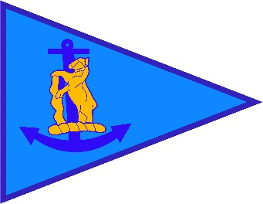

#### HOEOCA Limited

Proxy Form

I, (Full Name)

of

(Full Address)

being a member of HOEOCA Limited hereby appoint **The Commodore \***

**or\*** (Full Name of Proxy)

of

(Full Address of Proxy)

as my proxy to vote for me on my behalf at the Extraordinary General Meeting of the Association to be held on Tuesday 3rd September 2024, and at any adjournment thereof.

Signed

Date

Please return this completed Proxy Form by 8.30pm on Sunday 1st September 2024 to David Reed, Commodore, HOEOCA Limited by email to [hoeoca.commodore@gmail.com](mailto:hoeoca.commodore@gmail.com)

For Against

|  |  |  |
| --- | --- | --- |
| To Approve the changes to Articles of Association Section 6.0 Subscription. |  |  |