Time To Talk – Lancashire Mind Wellbeing at Work Conference 2022
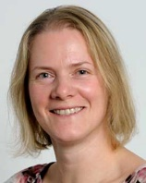
Dr Paula Holland is a Senior Lecturer in Public Health at Lancaster University. She has been active in co-developing Lancaster University’s wellbeing strategy. Paula has a long track record in conducting research on work, health and disability. She is currently researching disabled workers’ experiences of homeworking and hybrid working during the pandemic, and how hybrid working can be designed to be inclusive for disabled workers. Paula’s other research includes the impact of disability and long-term health conditions on the ability to work, and identifying effective interventions to support their work retention and return-to-work.

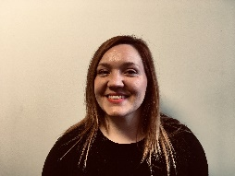
Emma Mamo is the Head of Workplace Wellbeing at Mind. Emma joined Mind in 2007 and, since 2010, has led Mind’s campaigning for mentally healthy workplaces - playing a pivotal role in thought leadership to position mental health in the workplace as a key priority for employers and Government. Emma has led culture change through engagement with employers, health and safety professionals, HR audiences and Government on mental health in the workplace and back-to-work support for people with mental health problems. She also supports networks of employers and stakeholders to share best practice and develop business-to-business peer support.
Emma’s prior role at Mind was as Policy and Campaigns Manager of the Social Inclusion and Rights team, leading on promoting social inclusion and upholding the human rights of people with mental health problems across the following areas: employment; benefits and welfare reform; debt and poverty; access to the criminal justice system; and equality and discrimination law. During this time, Emma led Mind’s successful national campaigns ‘Taking care of business: mental health at work’ and ‘In the red: debt and mental health’, both achieving awards and recognition for impact and innovation.
Emma has worked in the disability sector since 2005 and previously worked for Mencap, the learning disability charity.

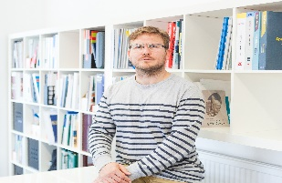
Ben Goode is the Chief Executive Officer at LSI Architects, an AJ100 listed architectural practice based in London and Norwich.

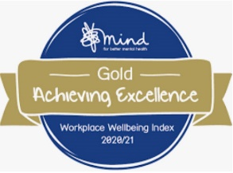
Ben has been the driving force behind LSI Architects’ initiative to prioritise mental health, and place greater emphasis on the concept of wellbeing which has since seen the practice ranked the best UK Employer for Workplace Wellbeing in Mind's Workplace Wellbeing Index 2020-21.

Ben is a passionate advocate of raising the profile of mental health and wellbeing in the workplace, derived from his own personal experiences. He was responsible for introducing the initiative to the board, achieving sign off and creating the relationships with expert external collaborators who have been so crucial to the initiative’s success.

Ben’s talk will share a number of “lessons learned” and tips around implementing a workplace wellbeing initiative from his experience of doing so at LSI Architects that could help others on their own journey in this area.
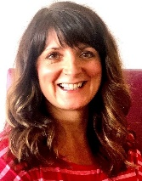
Deborah Kelly, Mindfulness Coach, Facilitator and Teacher.
I began my mindfulness journey after a stressful period in my life. I started to feel anxious, and as a perfectionist I was putting myself under more and more pressure at home and at work. I was feeling overwhelmed and started to have panic attacks. I felt I had to do something about it as it was starting to stop me doing things that I ordinarily would do.

Mindfulness meditation apps really helped me, and I was curious to see if I could develop this further having heard how good for you mindfulness can be. What really made the difference for me was going on a mindfulness course to learn and experience more about how it works. I believe mindfulness is a life skill having learnt how to manage my thoughts (rather than letting them overwhelm me), understanding the science around the mind, body and emotions, so that I can now enjoy the moment and my life more fully.

Mindfulness made such a difference to me that I made a career change, leaving my Head of Function senior role in financial services to train with MIND to become a qualified Mindfulness Teacher. It is a joy to get feedback from people attending my courses and workplace sessions, saying it has been incredible in terms of the difference Mindfulness has made to their lives.
I now work for myself having set up my company ‘Your Best Life’ and enjoy working with individuals, groups and organisations running Mindfulness for Stress, Resilience and Wellbeing programmes. I also work as a freelance Mindfulness Coach and volunteer for MIND. As a Mental Health First Aider, I am passionate about physical and mental wellbeing.

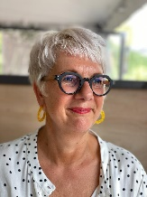
Jo Smith is Lancashire and South Cumbria Foundation Trusts Health and Wellbeing Strategic Lead, her areas of expertise are Public Health, behaviour change and leadership.
Jo’s NHS career began 16 years ago supporting the delivery of a 5 A DAY initiative, working across East Lancashire with a range of communities, her people skills, ability to motivate and educate being utilised to the full. Becoming part of a Health Improvement Service Jo was the Public Health Specialist for nutrition, a role which supported action on obesity from a population perspective. Appointed as Health Coordinator within this service Jo managed a team of Public Health Lifestyle Advisors whilst jointly supporting work within the Trust on developing approaches to workplace health and wellbeing.
Jo now has 6 years’ experience in workplace health and wellbeing, she recently undertook a Masters in Healthcare Leadership and applies compassionate and collective leadership theory to drive positive change. Working strategically on embedding a sustainable approach, Jo uses Public Health methodology she remains passionate about the prevention of ill health, leadership and supporting people in ‘working well’.

MARK STERLING, Lived In Expert, Gambling Harm.
Mark is a 54-year old ex-accountant with over 30 years' experience within the finance sector. Mark is also a reformed gambling addict with 7 convictions for fraud, living in a shared house and on prison licence until June 2023.
This presentation will serve to highlight the triggers, the roller coaster lifestyle, the devastation and destruction of relationships and the ultimate life or death decisions which have afflicted Mark over 40 years of addiction.
The childhood issues, the teenage battles and eventually the adult criminality which resulted in the loss of everything Mark held dear.
Now, 8 years gambling free, it is time to talk openly and candidly about this life destroying subject. Family, friends and work colleagues need to be able to notice and discuss problem gambling, as this technological age can bring the casino or the bookies right into our homes or workplaces 24 hours a day. It’s the invisible addiction.

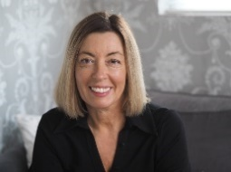
Sarah Cale menopause Commentator. Founder of Positive Menopause Community Support and workplace education. Menopause speaker who has provided contributions for Hello magazine online, BBC5 Live, Platinum Magazine, Simply women and home, Industry Leaders and BBC Hereford. Affiliated with Wellbeing of women, which involved being part of two zoom meetings with HRH the Countess of Wessex and Carolyn Harris MP. Following on from Sarah’s menopause she took the initiative to start a community support group for women like her that were struggling.

Her mission now is to continue supporting as many women as possible within the community and in the workplace. She also intends to educate men to build unity and support in all areas of life.

