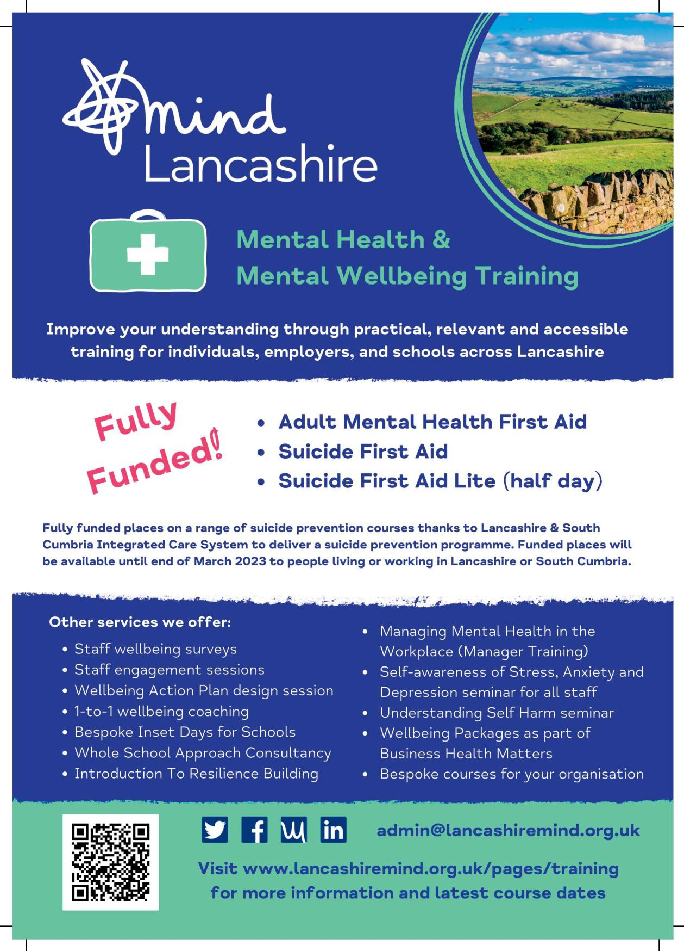

Well done for completing the Adult Mental Health First Aider England virtual/face to face course. As a Mental Health First Aider you may be wondering what your next steps might be... Within this pack we have listed some tips for both individual and teams of MHFA'ers operating in workplaces; and also individuals operating as MHFA'ers within the community, to create a sustainable offer. Alongside this we've added some self care reminders to support you in your role as a MHFA'er.

We hope that you find these tips beneficial in setting up and running a sustainable support offer safely to those around you.

Pack Contents
Helpful Tips When Supporting Colleagues At Work
Helpful Tips When Supporting Colleagues At Work As Part Of A Team Helpful Tips When Supporting People Within Your Community
Orange Button Community Scheme Advocating For Positive Mental Wellbeing Taking Care Of You

Helpful Tips When Supporting Colleagues At Work

- Ensure you have the support of your manager/supervisor and HR to undertake this role.
- Ensure you have the time to give to this role. Just because the role relates to mental health and emotional wellbeing that does not mean you should be on call 24/7. A First Aider for physical health would only be contacted during working hours and at other times employees would be expected to use other forms of support. This should be the same for a MHFA'er. You should not be doing this role after work, on your days off, during your annual leave, in your lunch, or at breaks, as this is 'your' time and it is essential for your wellbeing.

- Think about what support options are available for you, especially if you are the only MHFA'er. Supporting others can be very rewarding but it can also be difficult at times and you need to be able to prioritise your own wellbeing, otherwise you will become unable to continue helping others. If at any point you find the role is too much, then it is okay to take a break. Modelling good self care can be a way of helping other people or of causing positive change in relation to mental health, as it is a form of leading by example. There is a section on self care later in this guide.
- If you are the only MHFA'er at your organisation, ask yourself whether you alone are enough to support the number of employees in the workplace. It's okay to ask for help.

- Monitor how much time you are spending undertaking the role. If it is taking up too much time, perhaps you need more MHFA'ers for your organisation and by monitoring the time it is taking you can go back to your managers or HR team and evidence why more trained supports are needed or encourage them to consider other support options.

- Refresh your mind with the organisation's current workplace wellbeing off er so you can encourage others to utilise offers of support and take part in activities.

- Refresh your mind with the organisation's Safeguarding, Mental Health/Wellbeing, GDPR and Alcohol/Drug Policies. If your organisation doesn't have a policy, perhaps this is something you need to encourage.

- Gather your resources together, you don't need to know everything or have resources for everything! Gather some leaflets or print out some physical signposting information and keep them in a file so you can hand them out to people as needed. Keep to recognised organisations and charities for information and helplines. We know there is a lot of helpful information online but we also know there is a lot of unhelpful information on the internet too. We can't check everything for safety, staying with recognised sources ensures we are trying to keep people as safe as possible.

- Consider the support options available outside of your usual working hours. It can be harder to set healthy boundaries around your role if you are worried about a lack of support for people within your workplace, other than yourself. Thinking about what you will say if you are contacted out of hours and having a list of helpline numbers to offer as an alternative, and details of the company EAP (employee assistance program) if you have one, can make it easier to step away.

- Remember the limitations of your role and the training you have received. Those contacting you might not realise you are not the same as a counsellor, employment law expert or mental health professional in the same way they would usually understand a physical First Aider is not a GP or surgeon. Sometimes stepping away and encouraging those looking to you for support to reach out to other people is the most helpful thing you can do for them, even if they are distressed or you really want to offer more.

- Maintain personal boundaries and privacy. You may give your personal phone number to a friend for support, but you might not want to do that with a colleague who is not a friend. To set boundaries and help you operate within internal GDPR and Data Protection policies, it is better practice to use your work emails and work mobile/land line numbers only. This is both to protect your wellbeing and that of the people you are supporting.
- Think about how the role will be promoted internally. Setting clear expectations early on and in company information about the MHFA'er role can really help, such as a statement employees should use alternatives outside your working hours and having helpline numbers, EAP details and encouragement to contact a GP, 111 or 999 in an emergency, published alongside the information about your role. An example might be a poster with the MHFA'ers names and contact details on it, alongside a list of support options under another heading such as 'support outside normal working hours', '24/7 support options' 'immediate help' or 'in an emergency'. You could ask for a similar list to be put in the Company Handbook or on the company intranet. Some MHFA'ers choose to include a safeguarding statement letting others know they have to abide by the organisation's Safeguarding policy and procedures as part of their role on promotional materials. You could wear a lanyard, badge or add that you are a MHFA'er to your email signature block along with a note you are only available at certain times, perhaps with the Samaritans 24/7 free helpline number alongside it, as an out of hours support option. You could use wall signs, leaflets, or you could be named on the organisation's induction manual. Think about how people are going to reach out to you. Can they be referred from management/HR? Are you going to be available anytime during your working hours or is it appointment only. Can they email/phone for a quick chat or is it going to be face to face only? There is no right or wrong, it's what works for you and your organisation. However, whatever is decided should be clearly communicated, especially if this is the first time your organisation has had an MHFA'er.

- Take notice of your organisation's quiet places so you can have a confidential conversation with someone. If you don't have any (or many) it's okay to walk and talk and have the conversation outside.

- If you are going to keep records about someone, it's important that they are aware that you are keeping records as this may influence what they share with you. If you've been asked to do this and feel awkward telling people, perhaps you can ask for it to be added to the promotional material for the role. You must always abide by your organisation's GDPR and Data Protection policies, remember even note pads are counted into this. If you don't have permission to keep records from either the individual or your organisation, you shouldn't be keeping records of people's personal information.

- Consider what you might do if you have to break confidentiality because of a safeguarding concern. Not everybody will realise that you may have to break confidentiality. You yourself may be concerned with the consequences of your actions for that person and your relationship with them. Remember safeguarding is everyone's responsibility and your organisation has a responsibility for the wellbeing of all it's staff; only a coordinated response will ensure we keep vulnerable adults, children and young people safe. If you have attended safeguarding training before, for either adults or children/young people, it might be a good idea to refresh your knowledge. If this concept is new to you, this might be a good time to upskill. If you have any concerns you may have a safeguarding lead within your organisation you can discuss this with or you can speak to the Adult/Child Safeguarding Team in your area. It is not your role to personally investigate safeguarding concerns. You may also have to reach out to emergency services for someone if they are not able to keep themselves safe or you think someone else may be at risk of harm. Discuss with your HR Team and find out whether there is a policy in place and ensure it fits with the role you will be
undertaking.

Helpful Tips For Supporting Colleagues At Work As Part Of A Team

Alongside the general tips for operating as an MHFA'er within your workplace, having a team of MHFA'ers can make you feel more supported in the role.

- Talk to other MHFA'ers to find out what is already in place and what you need. You can then nominate a spokesperson to speak to HR, or collectively have a meeting to express your requirements to undertake the role.

- Set up a peer support group either physically or virtually to ensure you all have someone to talk to who understands the role. This can be a great way to support each other, unload and to share tips or advice. Sometimes people feel very alone or unsure when undertaking the role and MHFA'ers might work in different teams/departments and never meet another MHFA'er at the organisation. It's also a great opportunity to ensure the programme is working as it should and to identify any common trends in the wellbeing concerns being brought to you, which you could anonymise to pass on to HR or senior management, so improvements can be made.

- Work with other MHFA'ers to refer those who need support to the right person in the team, for everyone's wellbeing. Not all MHFA'ers are as comfortable with some subjects or supporting specific people, as a topic might be too close to a negative personal experience. If boundaries have broken down, then stepping away and suggesting contact with another MHFA'er can protect the original MHFA'ers needs while continuing to provide appropriate support.

- Some MHFA'ers have dedicated MHFA files and each carry the same resources to ensure consistency for all staff receiving support. They also carry a list of the contact details for fellow inhouse MHFA'ers in case they are not available or go on leave.

- Some organisations organise CPD events for their MHFA'ers to ensure they remain relevant and knowledgeable.

Helpful Tips For Supporting People Within Your Community

- Ensure you have a healthy balance around supporting others and make time for other people in your life. As someone operating independently it can be more difficult to create personal boundaries or recognise how much time you are giving to others. You are important too. Looking after yourself could also be what another person needs to see to feel they have permission to be kinder to themselves and it can contribute to building a better culture around mental health. Try to treat yourself as you would want those you are supporting to treat themselves, or how you would want someone you love to treat themselves.

- Think about what support options are available for you, especially if you are the only community MHFA'er you know. Supporting others can be very rewarding but it can also be difficult at times and you need to be able to prioritise your own wellbeing, otherwise you will become unable to continue helping others. If at any point you find the role is too much, then it is okay to take a break. There is a section on self care later in this guide.

- Gather your resources together, you don't need to know everything or have resources for everything! Gather some leaflets or print out some physical signposting information and keep them in a file so you can hand them out to people as needed. Keep to recognised organisations and charities for information and helplines. We know there is a lot of helpful information online but we also know there is a lot of unhelpful information on the internet too. We can't check everything for safety, staying with recognised sources ensures we are trying to keep people as safe as possible.

- Maintain personal boundaries and privacy. You may give your personal phone number to a friend for support, but you might not want to do that with everyone. Let people know when you are and when are not available. It's not good for your wellbeing to be available 24/7. You might have a badge, lanyard or sticker you only use when you are on duty or feel comfortable being approached. By taking care of yourself you are leading by example, and will encourage others to do the same.

- Consider the support options available for people outside of your usual availability. It can be harder to set healthy boundaries around your role and to relax if you are worried about a lack of support for people, other than yourself. Thinking about what you will say if you are unavailable or need to end an interaction, and having a list of helpline numbers to offer as an alternative, can make it easier to step away. You might want to set up an email address just for your MHFA'er role, and put the 24/7 helpline number for the Samaritans in the email signature, with a note this can be used when you are not available or in a time of crisis. If you support people on line via social media or a forum, you could ask for the admin to add a pinned list of alternative, emergency, or

email signature, with a note this can be used when you are not available or in a time of crisis. If you support people on line via social media or a forum, you could ask for the admin to add a pinned list of alternative, emergency, or 24/7 support options, such as helplines, or do this yourself. An 'immediate help' button could be added to a website with a list of helpline numbers and links to recognised charities.
- Remember being an MHFA'er doesn't mean you are offering long term support, it is not a therapy session, you are not a replacement for professional support. If you choose to stay in someone's life as an additional or other support, that is your choice, but you may not want to do that with everyone.
- Remember the limitations of your role and the training you have received. Those contacting you might not realise you are not the same as a counsellor, employment law expert or mental health professional in the same way they would usually understand a physical First Aider is not a GP or surgeon. Sometimes stepping away and encouraging those looking to you for support to reach out to other people is the most helpful thing you can do for them, even if they are distressed or you really want to offer more.
- Generally, MHFA'ers do not keep notes or records on the people they are supporting. If you are going to keep records about someone, just to remind you what you need to do, it's important that they are aware that you are keeping records as this may influence what they share with you. Although you may not see your role as professional, they might, and it is important to keep people's information safely.
- Consider what you might do if you have to break confidentiality because of a safeguarding concern. Not everybody will realise that you may have to break confidentiality. You yourself may be concerned with the consequences of your actions for that person and your relationship with them. Remember safeguarding is everyone's responsibility it is only by working with others that we can keep people safe. If you have attended safeguarding training before, for either adults or children/young people, it might be a good idea to refresh your knowledge. If this concept is new to you, this might be a good time to upskill find out what is available on line or in your area. If you have any concerns you can speak to the Adult/Child Safeguarding Team in your area. It is not your role to personally investigate safeguarding concerns. You may also have to reach out to emergency services for someone if they are not able to keep themselves safe or you think someone else may be at risk of harm.
- Consider other training you may feel beneficial to you and begin to find out what is available in your area. Some courses are commissioned, which means they are free or reduced cost, these can support you to remain relevant and upskilled in your knowledge around mental health.

Orange Button Community Scheme

After completing the Adult Mental Health First Aid course (either virtual or face to face) you are entitled to become an Orange Button Holder. The Orange Button initiative is promoted by Healthier Lancashire and South Cumbria' Integrated Care System and Orange Button applicants will receive a badge, window sticker, support card and local suicide prevention signposting information. The Orange Button symbol signifies to others that you:
Can be approached to talk about suicide.
You are a connector, a first point to start a conversation.
You are a non-judgemental, caring and understanding listener.
You can give signposting support and information around suicide prevention. You are somebody who can ask and can be asked directly about suicide.

If you have attended a virtual session, you should have been sent a link to apply for an Orange Button. If you have attended a face to face session since April 2020 the trainer should have carried Orange Button's with them for any learners who would like one.
If you have not received your Orange Button or have now decided that you would like to become an Orange Button holder, please contact admin@lancashiremind.org.uk for more information.

If you do not yet feel you have the skills or knowledge to be an Orange Button holder, consider attending either a virtual or face to face half day Suicide First Aid Lite course to give you the skills to take someone from a place of danger and isolation, to a place of safety and support. Get in touch with admin@lancashiremind.org.uk to find out more details.
Alternatively, you could be eligible to undertake a City and Guilds qualification in Suicide Prevention by attending a full day Suicide First Aid course and registering with City and Guilds. If this interests you, please get in touch.

Advocating For Positive Mental Wellbeing

Advocating for positive mental wellbeing and raising awareness helps encourage early intervention and prevention strategies to support the wellbeing of all those around us. Not everyone has had the opportunity you have received to learn about mental health or how to maintain their mental wellbeing overall, as a certified MHFA'er you are in a great position to encourage workplaces, communities and individuals to embed resilience building, encourage positive coping strategies and challenge stigma.
If you would like to know more about what you as an individual within the community can do to advocate for positive mental wellbeing through our volunteering, charity fundraising or
community engagement then please get in touch. If you are within a workplace and would like to know more about how Lancashire Mind can support your workplace through training, one to one wellbeing coaching or our workplace survey; then please contact us at admin@lancashiremind.org.uk

Taking Care Of You

Remember listening to other people's stories can begin to take an emotional toll. The MHFA'er role is voluntary, step away if you need to. Taking care of you is a priority, nobody can pour from an empty cup.

Make Time To Refocus
If you have just had a difficult conversation, it can be very difficult for both of you to refocus and if you've had to end the conversation because of time pressure it can make you feel bad for both of you. It's a great idea to ask them what they're going to do now, feel free to make suggestions such as taking a break at work, going for walk outside, phoning a friend and talking about something different. In the same breath, ask yourself what are you going to do next? If you feel okay getting back to your normal routine that's okay, but if you need an emotional reset do something to boost your own wellbeing too. It could be as simple as making yourself a cup of tea or coffee and taking a break to look out a window, or spending time with a pet.
Find Your Own Supports
Talking to others can help you too, remember, peer support is built on trust, you must maintain confidentiality and privacy, unless there is a safeguarding concern. But you can tell someone else you've had a challenging experience and tell them how it made you feel. Talking it over can really help, if you don't feel you can talk to anyone you know, Samaritans help line offer a fantastic confidential service just to help you get it out of your system and feel better.
Positive Affirmations
Perhaps you have wanted to 'fix it' for someone or you don't feel you're living up to their expectations. Remember it's hard to fix things with words alone. Don't put that added pressure on yourself. Being an empathetic listening ear can be all someone needs to feel better in that moment, knowing someone cares enough to give them time can make someone feel they are not alone.
"I am doing a great job."
"I have made a difference."
"Just being there was enough in that moment."
Setting Boundaries
Both yourself and the person you are supporting are allowed to have personal boundaries. Not everyone will want to be reminded of the conversation you've just had which can be hard as the MHFA'er as you might want to know how they are doing. When someone has shared their story with you, you might ask them if it's okay to check in or give them more information if you find it.

You are entitled to set your boundaries too. Remember you are not a replacement for professional support. You don't have to be available 24/7, set expectations early on. If you are doing this role at work, you will probably have another role as well. The final 'E' in ALGEE is a great reminder to create a toolkit of supports for someone, especially when they are in crisis. You can remain in that network of support if you choose but it's great practice to ensure you're not alone. That individual may have other positive supports such as
family/friends/colleagues that they can reach out to, there are other great supports out there and crisis lines that can support someone besides you.
Step Away If You Need To
If you have a lot going on either at work or in your own personal life, you might not feel you
are able to give the role a 100%; give yourself permission to step away. If you are at work you can purchase MHFA lanyards or badges, which signify whether you are available to talk or not (remember to let others know what the lanyards and badges signify.)
If someone's story is starting to affect you, remember the 'window on the world activity' we all have different perspectives. Be honest with yourself, am I the right person to deal with this? Are my personal experiences going to create a bias in how I talk about this? Is there going to be a personal emotional cost for me to support this person with this problem? It's okay to acknowledge what they are going through and explain that this is not something you can talk about right now, but signpost them to other support options or ask them if another MHFA'er who is able to have that conversation can get in touch.
Maintain Your Own Long Term Wellbeing
Spending time on you is not a waste of time. Remember the Five Ways to Wellbeing and Ten Ways to Happier Living in your MHFA manual. These are evidence based to improve long term wellbeing and some of the simple things you can embed into your own daily routine to improve positive mental wellbeing. Self care isn't selfish, but rather something that will help you to continue to be there for other people and a way to show others how to be kind to or value themselves.
If You're Worried Nobody Is Reaching Out For Your Support
First of all make sure you are being adequately promoted, you may want to ask people who have had positive experiences with you to share their experience for marketing purposes if you are operating as an MHFA'er at work, leaving out any personal details which highlight any challenges they have had. We don't want to make them feel vulnerable or expose them unnecessarily to awkward questions. However, it might be because everyone is doing okay, which is something which should be celebrated. Don't take it personally! Maintain your own wellbeing and sense of purpose by getting involved in other wellbeing events which are going on and which maintain your profile across your community/organisation. Keep taking care of yourself and leading by example.

