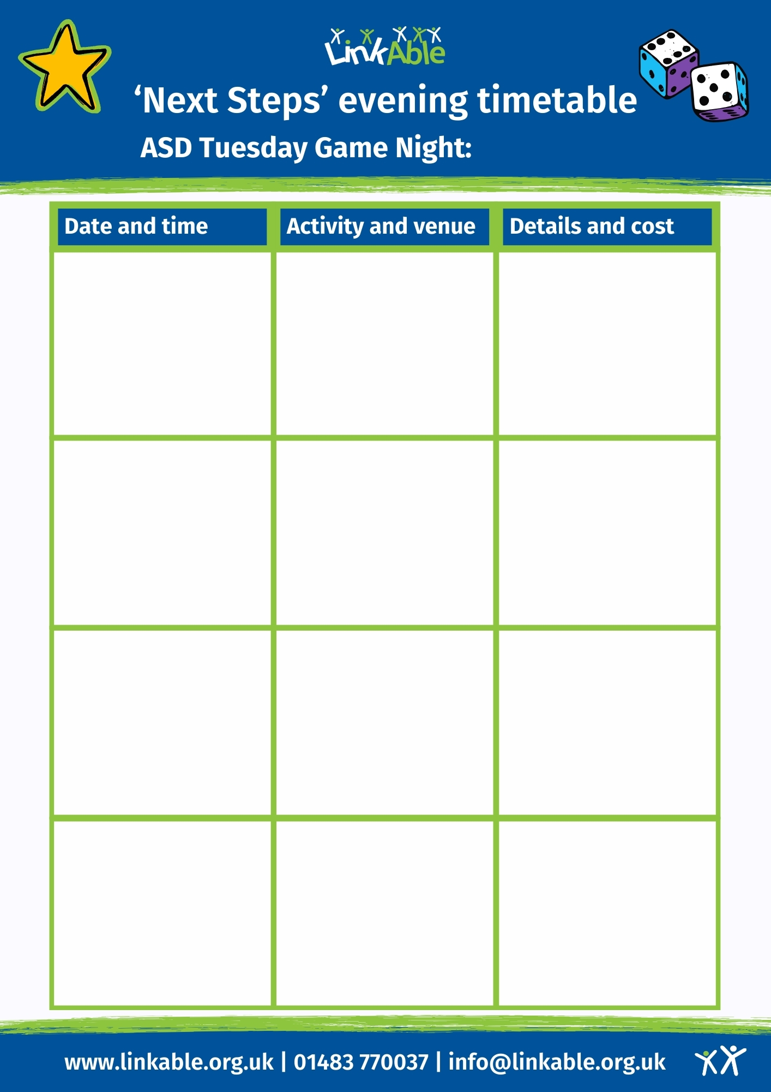

**September**

**LinkAble Bake-Off**

**Cupcake making and decorating**

**£8 subs**

**16th September**

**@LinkAble**

**6:45pm – 8:45pm**

**Movie Night**

**Snacks and movie enjoyed with friends**

**£8 subs**

**23rd September**

**@LinkAble**

**6:45pm – 8:45pm**

**Mad Scientists**

**Science- themed sensory play and exploration**

**£8 subs**

**30th September**

**@LinkAble**

**6:45pm – 8:45pm**

**9th September**

**@LinkAble**

**6:45pm – 8:45pm**

**Collage Making**

**Hobbies and interests arts and crafts**

**£8 subs**